
University Pro Forma |
Disclaimer

The University Pro Forma serves as a guide for the most common financial reporting scenarios applicable to UNC System institutions; however, financial reporting rests solely with management of each institution. Each institution’s financial statement package should be modified to reflect the specific institution.
The University Pro Forma does not reflect all potential GASB requirements that could apply to each institution. Refer to the GASB Codification to determine all financial reporting requirements applicable to each institution.
Note to Preparers: The tables in this document are best experienced when Word is optimized for best appearance under options. Also, it is recommended that users do not roll forward older tables. Older tables may not be compatible with OSA audit applications.



Management’s Discussion and Analysis

Note to Preparer: Effective for fiscal year 2026, GASB Statement No. 103, Financial Reporting Model Improvements, introduces updated requirements for Management’s Discussion and Analysis. Refer to paragraphs 4 through 8 for detailed guidance on these requirements.

Insert Management’s Discussion and Analysis Here

Financial Statements
Insert Financial Statements Here

Notes to the Financial Statements
[Note to Preparer 1: If preparing rounded statements ensure that all cents are removed from cell values entirely (i.e., do not just hide cents via cell formatting) to ensure charts will properly foot and crossfoot.]
[Note to Preparer 2: Disclosures have been provided for the most common items reported on the Statement of Fiduciary Net Position and Statement of Changes in Fiduciary Net Position. However, additional disclosures may be required for the specific items reported. Refer to GASB Statement No. 84 and GASB Implementation Guides.]

Note 1 - Significant Accounting Policies
A. Financial Reporting Entity - The concept underlying the definition of the financial reporting entity is that elected officials are accountable to their constituents for their actions. As required by accounting principles generally accepted in the United States of America (GAAP), the financial reporting entity includes both the primary government and all of its component units. An organization other than a primary government serves as a nucleus for a reporting entity when it issues separate financial statements. *1 (University) is a constituent institution of the multi-campus University of North Carolina System, which is a component unit of the State of North Carolina and an integral part of the State’s Annual Comprehensive Financial Report.
The accompanying financial statements present all funds belonging to the University and its component unit(s). While the Board of Governors of the University of North Carolina System has ultimate responsibility, the Chancellor, the Board of Trustees, and the Board of Trustees of the Endowment Fund have delegated responsibilities for financial accountability of the University’s funds. The University’s component unit(s) are either blended or discretely presented in the University’s financial statements. See below for further discussion of the University’s component unit(s). Other related foundations and similar nonprofit corporations for which the University is not financially accountable are not part of the accompanying financial statements.
Financial statements for the University and its blended and discretely presented component units are presented as of and for the fiscal year ended June 30, 2026, except for ___________ Foundation whose financial statements are as of and for the fiscal year ended ________. [Omit this paragraph if no differing fiscal year ends.]
Blended Component Unit(s) - Although legally separate, ____________ (Foundation) and ___________ (Investment Fund), component units of the University, are reported as if they were part of the University.
[Provide a brief description of the component units, and explain their relationship to the primary government, the rationale for including each component unit in the reporting entity and how to obtain a copy of their financial statements - examples follow - MODIFY AS NECESSARY.]
The Foundation is governed by a __-member board consisting of __ ex officio directors and __ elected directors. The Foundation’s purpose is to aid, support, and promote teaching, research, and service in the various educational, scientific, scholarly, professional, artistic, and creative endeavors of the University. Because the elected directors of the Foundation are appointed by the members of the *1 Board of Trustees and the Foundation’s sole purpose is to benefit *1, its financial statements have been blended with those of the University.
The Investment Fund is governed by a board consisting of __ ex officio directors and ____ elected directors. The Investment Fund’s purpose is to support the University by operating an investment fund for charitable, nonprofit foundations, associations, trusts, endowments, and funds that are organized and operated primarily to support the University. The Investment Fund is a governmental external investment pool. Because the elected directors of the Investment Fund are appointed by the members of the *1 Board of Trustees and the Investment Fund’s primary purpose is to benefit *1, its financial statements have been blended with those of the University.
Separate financial statements for the Foundation and the Investment Fund may be obtained from the University Controller’s Office, [provide address], or by calling [revise as necessary, including telephone number].
Condensed combining information regarding blended component units is provided in Note XX.
[Disclose all significant transactions between the University and its major blended component units in Note 23 of the Pro Forma.]
Discretely Presented Component Unit(s) - __________ Foundation and ____________ Foundation are legally separate nonprofit corporations and are reported as discretely presented component units based on the nature and significance of their relationship to the University.
[Explain the basis for including each component unit in the reporting entity and how to obtain a copy of their financial statements. Examples follow. MODIFY AS NECESSARY. If only one component unit, modify the sentence above and the first sentence of each paragraph below to eliminate redundancy.]
The ___________ Foundation acts primarily as a fundraising organization to supplement the resources that are available to the University in support of its programs. The Foundation board consists of __________. Although the University does not control the timing or amount of receipts from the Foundation, the majority of resources, or income thereon, that the Foundation holds and invests are restricted to the activities of the University by the donors. Because these restricted resources held by the Foundation can only be used by, or for the benefit of the University, the Foundation is considered a component unit of the University and is reported in separate financial statements because of the difference in its reporting model, as described below.
The ______________ Foundation is a private nonprofit organization that reports its financial results under the Financial Accounting Standards Board (FASB) Codification. As such, certain revenue recognition criteria and presentation features are different from the Governmental Accounting Standards Board revenue recognition criteria and presentation features. No modifications have been made to the Foundation’s financial information in the University’s financial reporting entity for these differences.
[Disclose all significant transactions between the University and its major discretely presented component units.]
During the year ended June 30, 2026, the Foundation distributed $__________ to the University for both restricted and unrestricted purposes. Complete financial statements for the Foundation can be obtained from ________________________.
B. Basis of Presentation - The accompanying financial statements are presented in accordance with accounting principles generally accepted in the United States of America as prescribed by the Governmental Accounting Standards Board (GASB).GASB Statement No. 34, Basic Financial Statements - and Management’s Discussion and Analysis - for State and Local Governments, as amended by GASB Statement No. 35, Basic Financial Statements - and Management’s Discussion and Analysis - for Public Colleges and Universities, and GASB Statement No. 84, Fiduciary Activities, require the presentation of both proprietary and fiduciary fund financial statements. See below for a description of each fund.
Proprietary Fund - This fund accounts for the University’s primary activities and is presented in a single column on the accompanying proprietary fund financial statements.
Fiduciary Fund(s) - This fund accounts for all of the University’s fiduciary activities, which are considered custodial funds. These resources are held by the University in a purely custodial capacity on behalf of individuals, affiliated organizations, and other external parties. Custodial funds include the external portion of an investment pool sponsored by the [sponsor], as well as resources held on behalf of [other parties] for [insert nature of fiduciary activity]. [Modify as necessary to disclose the specific nature of report fiduciary fund types]
For the fiscal year 2026, the University implemented GASB Statement No. 103, Financial Reporting Model Improvements. This Statement amends the existing financial reporting model to enhance the relevance, consistency, and comparability of the financial statements. The University has modified its Statement of Revenues, Expenses, and Changes in Net Position to define and separately report noncapital subsidies immediately following operating income/loss
OR
[If the University is not reporting Fiduciary Activity use this option.]
B. Basis of Presentation -The accompanying financial statements are presented in accordance with accounting principles generally accepted in the United States of America as prescribed by the Governmental Accounting Standards Board (GASB). Pursuant to the provisions of GASB Statement No. 34, Basic Financial Statements - and Management’s Discussion and Analysis - for State and Local Governments, as amended by GASB Statement No. 35, Basic Financial Statements - and Management’s Discussion and Analysis - for Public Colleges and Universities, and GASB Statement No. 84, Fiduciary Activities, the full scope of the University’s activities is considered to be a single business-type activity and accordingly, is reported within a single column in the basic financial statements.
For the fiscal year 2026, the University implemented GASB Statement No. 103, Financial Reporting Model Improvements. This Statement amends the existing financial reporting model to enhance the relevance, consistency, and comparability of the financial statements. The University has modified its Statement of Revenues, Expenses, and Changes in Net Position to define and separately report noncapital subsidies immediately following operating income/loss
C. Basis of Accounting - The financial statements of the University have been prepared using the economic resource measurement focus and the accrual basis of accounting. Under the accrual basis, revenues are recognized when earned, and expenses are recorded when an obligation has been incurred, regardless of the timing of the cash flows.
Nonexchange transactions are those in which the University receives (or gives) value without directly giving (or receiving) equal value in exchange. In accordance with GASB Statement No. 103, Financial Reporting Model Improvements, nonexchange transactions that directly or indirectly keep the University’s student fees and charges lower than they would be otherwise are classified as noncapital subsidies. Noncapital subsidies, such as state appropriations and donations for scholarships, are reported separately from other nonoperating activities immediately following operating income (loss) to establish a combined "Operating Income (Loss) and Noncapital Subsidies" subtotal. Revenues are recognized, net of estimated uncollectible amounts, as soon as all eligibility requirements imposed by the provider have been met, if probable of collection.
D. Cash and Cash Equivalents - This classification includes undeposited receipts, petty cash, cash on deposit with private bank accounts, cash on deposit with fiscal agents, and deposits held by the State Treasurer in the Short-Term Investment Fund (STIF). The STIF maintained by the State Treasurer has the general characteristics of a demand deposit account in that participants may deposit and withdraw cash at any time without prior notice or penalty. [Modify as deemed necessary for other cash equivalents]
E. Investments - To the extent available, investments are recorded at fair value based on quoted market prices in active markets on a trade-date basis. Additional information regarding the fair value measurement of investments is disclosed in Note 3. Because of the inherent uncertainty in the use of estimates, values that are based on estimates may differ from the values that would have been used had a ready market existed for the investments. The net change in the value of investments is recognized as a component of investment income. [Modify as deemed necessary.]
[Certificates of deposit, investment agreements, bank investment contracts, and other asset holdings] are reported at cost, if purchased, or at fair value or appraised value at date of gift, if donated. [Modify as deemed necessary.] [This paragraph should include all of the University’s investments that are not measured at fair value (i.e. investments not disclosed in Note 3.) See GASB Codification Section I50.121-123 for exceptions to fair value reporting.]
Endowment investments include the principal amount of gifts and bequests that, according to donor restrictions, must be held in perpetuity or for a specified period of time, along with any accumulated investment earnings on such amounts. Further, endowment investments also include amounts internally designated by the University for investment in an endowment capacity (i.e. quasi-endowments), along with accumulated investment earnings on such amounts. Land and other real estate held as investments by endowments are reported at fair value, consistent with how investments are generally reported. [Modify as deemed necessary.]
F. Receivables - Receivables consist of tuition and fees charged to students and charges for auxiliary enterprises’ sales and services. Receivables also include amounts due from the federal government, state and local governments, private sources in connection with reimbursement of allowable expenditures made pursuant to contracts and grants, and pledges that are verifiable, measurable, and expected to be collected and available for expenditures for which the resource provider’s conditions have been satisfied. Receivables are recorded net of estimated uncollectible amounts. [Modify as deemed necessary.]
G. Inventories - Inventories, consisting of expendable supplies, are valued at cost using either the first-in, first-out, last invoice cost, or average cost method. Merchandise for resale is valued at the lower of cost or market using the retail inventory method. [Modify as deemed necessary.]
H. Capital Assets - Capital assets are stated at cost at date of acquisition or acquisition value at date of donation in the case of gifts. Donated capital assets acquired prior to
July 1, 2015 are stated at fair value as of the date of donation. The value of assets constructed includes all material direct and indirect construction costs.
The University capitalizes assets that have a value or cost of $5,000 or greater at the date of acquisition and an estimated useful life of more than one year except for internally generated computer software which is capitalized when the value or cost is $1,000,000 or greater and other intangible assets which are capitalized when the value or cost is $100,000 or greater. In addition, grouped acquisitions of machinery and equipment that have an estimated useful life of more than one year but are individually below the $5,000 threshold are capitalized [when considered significant or when the group purchase exceeds $_______]. [Update to disclose the university’s capitalization policy for grouped assets]. [Note to preparer: Adjust to the University’s specific capitalization policy.]
Depreciation and amortization [Note: Remove ‘and amortization’ if it is not applicable to your entity] is/are computed using the straight-line and/or units of output method over the estimated useful lives of the assets in the following manner:
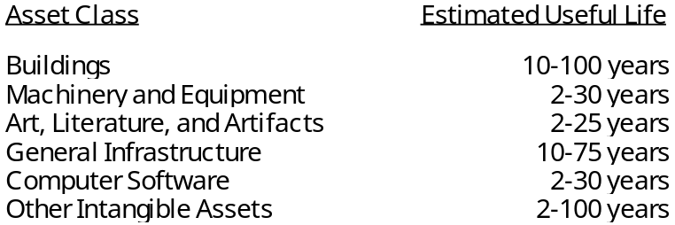
[Modify as necessary.]
The University does not capitalize the [fill in the title] collection(s). This/(These) collection(s) adhere(s) to the University’s policy to maintain for public exhibition, education, or research; protect, keep unencumbered, care for, and preserve; and require proceeds from their sale to be used to acquire other collection items. [Modify as necessary.] Accounting principles generally accepted in the United States of America permit collections maintained in this manner to be charged to operations at time of purchase rather than be capitalized. [Remove if no collections are not capitalized]
Right-to-use leased and subscription assets are recorded at the present value of payments expected to be made during the lease or subscription term, plus any upfront payments and ancillary charges paid to place the underlying right-to-use asset into service. Lease liabilities are capitalized as a right-to-use asset when the underlying leased asset has a cost of $_____ or greater and an estimated useful life of more than one year. Subscription liabilities are capitalized as a right-to-use asset when the underlying subscription asset has a cost of $_____ or greater and an estimated useful life of more than one year. [Note to preparer: Adjust to the University’s specific capitalization policy.]
Amortization for right-to-use leased and subscription assets is computed using the straight-line method over the shorter of the lease/subscription term or the underlying asset’s estimated useful life. If a lease agreement contains a purchase option the University is reasonably certain will be exercised, the right-to-use leased asset is amortized over the asset’s estimated useful life. [Remove if no right-to-use lease or subscription assets reported, modify as necessary]
I. Restricted Assets - Certain resources are reported as restricted assets because restrictions on asset use change the nature or normal understanding of the availability of the asset. Resources that are not available for current operations and are reported as restricted include resources restricted for the acquisition or construction of capital assets, resources legally segregated for the payment of principal and interest as required by debt covenants, unspent debt proceeds, and endowment and other restricted investments. [Modify as necessary.]
J. Accounting and Reporting of Fiduciary Activities - Pursuant to the provisions of GASB Statement No. 84, Fiduciary Activities, custodial funds that are normally expected to be received and disbursed within a 3-month period or otherwise do not meet the fiduciary activity criteria defined by GASB Statement No. 84 continue to be reported in the Statement of Net Position as funds held for others and as operating activities in the Statement of Cash Flows. [Delete if not applicable for your University.]
There are no other trust or custodial funds meeting the criteria of a fiduciary activity that are required to be reported in separate fiduciary fund financial statements.
OR
All trust or custodial funds meeting the criteria of a fiduciary activity are reported in separate fiduciary fund financial statements.
K. Noncurrent Long-Term Liabilities - Noncurrent long-term liabilities include principal amounts of long-term debt and other long-term liabilities that will not be paid within the next fiscal year. Debt is defined as a liability that arises from a contractual obligation to pay cash (or other assets that may be used in lieu of cash) in one or more payments to settle an amount that is fixed at the date the contractual obligation is established. Long-term debt includes: revenue bonds payable, special indebtedness, bonds/notes from direct placements, notes from direct borrowings, and bond anticipation notes. Other long-term liabilities include: arbitrage rebate payable, annuities and life income payable, pollution remediation payable, asset retirement obligations, lease liabilities, subscription liabilities, compensated absences, net pension liability, net other postemployment benefits (OPEB) liability, and workers’ compensation. [Modify as necessary.]
Revenue bonds payable and special indebtedness are reported net of unamortized premiums or discounts. The University amortizes bond premiums/discounts over the life of the bonds using the straight-line method that approximates the effective interest method. Deferred gains and losses on refundings are amortized over the life of the old debt or new debt (whichever is shorter) using the straight-line method, and are aggregated as deferred outflows of resources or deferred inflows of resources on the Statement of Net Position. Issuance costs are expensed in the reporting period in which they are incurred. [Modify as necessary]
The net pension liability represents the University’s proportionate share of the collective net pension liability reported in the State of North Carolina’s 2025 Annual Comprehensive Financial Report. This liability represents the University’s portion of the collective total pension liability less the fiduciary net position of the Teachers’ and State Employees’ Retirement System. See Note XX for further information regarding the University’s policies for recognizing liabilities, expenses, deferred outflows of resources, and deferred inflows of resources related to pensions.
The net OPEB liability represents the University’s proportionate share of the collective net OPEB liability reported in the State of North Carolina’s 2025 Annual Comprehensive Financial Report. This liability represents the University’s portion of the collective total OPEB liability less the fiduciary net position of the Retiree Health Benefit Fund. See Note XX for further information regarding the University’s policies for recognizing liabilities, expenses, deferred outflows of resources, and deferred inflows of resources related to OPEB.
L. Compensated Absences - The University accrues a liability for earned leave that carries over to future periods and is more likely than not to be used for time off or otherwise paid in cash or settled through noncash means. When determining the liability, leave is considered taken on a last in, first out (LIFO) basis.
Vacation Leave – Leave policies vary by employee group. For employees exempt from the North Carolina Human Resources Act, vacation is earned through the annual or personal leave programs established by the University of North Carolina Board of Governors. Leave is earned monthly and is subject to a maximum accumulated unused amount as of the end of each calendar year. The maximum amounts and the ability to convert amounts over the maximum to sick leave vary based on the program.
Bonus Leave – Bonus leave includes the special annual leave bonuses awarded by the North Carolina General Assembly. The bonus leave balance on December 31 is retained by employees and transferred to the next calendar year. It is not subject to the limitation on annual leave carried forward described above and is not subject to conversion to sick leave.
Sick Leave – Sick leave is earned monthly by eligible employees. The policy provides for the accumulation of unused sick leave to be carried forward until used. When employment is terminated, unused leave is forfeited or used to increase a member’s creditable service for employees participating in the North Carolina Teachers’ and State Employees’ Retirement System (TSERS). Based on a historical analysis of sick leave taken compared to sick leave earned, the liability for unused sick leave using the LIFO method was determined to be insignificant. Therefore, no sick leave liability is recognized on the financial statements
[Other Leave] – Other leave programs include unrestricted sabbatical leave, compensatory leave-off, parental leave, military leave, and civil leave. If a program is significant, identify the program and disclose university policy for recording a liability, otherwise disclosure not necessary]
[Revise wording to actual policy of the University, if different from above.]
M. Deferred Outflows/Inflows of Resources - Deferred outflows of resources represent a consumption of net assets that applies to a future period(s) and so will not be recognized as an outflow of resources (expense) until then. Deferred inflows of resources represent an acquisition of net assets that applies to a future period(s) and so will not be recognized as an inflow of resources (revenue) until then.
N. Net Position - The University’s net position is classified as follows:
Proprietary Fund [Delete if no fiduciary fund information presented separately]
Net Investment in Capital Assets - This represents the University’s total investment in capital assets, net of outstanding liabilities related to those capital assets. To the extent debt has been incurred but not yet expended for capital assets, such amounts are not included as a component of net investment in capital assets. Additionally, deferred outflows of resources and deferred inflows of resources that are attributable to the acquisition, construction, or improvement of capital assets or related debt are also included in this component of net position. [Delete last sentence in this paragraph if not applicable to your entity. Additionally, remove the word ‘Net’ from this paragraph’s heading if there are no liabilities related to capital assets at your institution. Liabilities related to capital assets include retainage payable and any accounts payable that are attributable to the acquisition, construction, or improvement of capital assets. See GASB Codification Section 2200.118 and 2200.709 for further guidance.]
Restricted Net Position - Nonexpendable - Nonexpendable restricted net position includes endowments and similar type assets whose use is limited by donors or other outside sources, and, as a condition of the gift, the principal is to be maintained in perpetuity.
Restricted Net Position - Expendable - Expendable restricted net position includes resources for which the University is legally or contractually obligated to spend in accordance with restrictions imposed by external parties.
Unrestricted Net Position - Unrestricted net position includes resources derived from student tuition and fees, sales and services, unrestricted gifts, royalties, and interest income. It also includes the net position of accrued employee benefits such as compensated absences, workers’ compensation, pension plans, and other postemployment benefits.
Restricted and unrestricted resources are tracked using a fund accounting system and are spent in accordance with established fund authorities. Fund authorities provide rules for the fund activity and are separately established for restricted and unrestricted activities. When both restricted and unrestricted funds are available for expenditure, the decision for funding is transactional based within the departmental management system in place at the University. For projects funded by tax-exempt debt proceeds and other sources, the debt proceeds are always used first. Both restricted and unrestricted net position include consideration of deferred outflows of resources and deferred inflows of resources. See Note XX for further information regarding deferred outflows of resources and deferred inflows of resources that had a significant effect on unrestricted net position.
Fiduciary Fund(s) [Delete if not applicable]
Restricted Net Position - Fiduciary net position includes resources held in a custodial capacity for [external pool participants in the University’s External Investment Fund, and/or for other individual, organizations, and governments] that are not available for alternative use by the University. [Modify as necessary to reflect actual circumstances - Delete if not applicable or significant for your University.]
O. Scholarship Discounts - Student tuition and fees revenues and auxiliary service revenues from University charges are reported net of scholarship discounts in the accompanying Statement of Revenues, Expenses, and Changes in Net Position. The scholarship discount is the difference between the actual charge for goods and services provided by the University and the amount that is paid by students or by third parties on the students’ behalf. In accordance with GASB Statement No. 103, Financial Reporting Model Improvements, student financial assistance grants, such as Pell Grants, and other federal and state need-based grants are recorded as operating revenue in the accompanying Statement of Revenues, Expenses, and Changes in Net Position. To the extent that revenues from these programs are used to satisfy tuition, fees, and other charges, the University has recorded a scholarship discount. The University utilizes the National Association of College and University Business Officers (NACUBO) guidelines for calculating the allocation of the scholarship discounts to tuition and fees revenues and auxiliary service revenues, which is based on an analysis of individual student account charges and financial aid payments from the student management information system.
P. Revenue and Expense Recognition - The University distinguishes operating revenues and expenses from noncapital subsidies, and other nonoperating revenues and expenses in the accompanying Statement of Revenues, Expenses, and Changes in Net Position. As defined by GASB 103, Financial Reporting Model Improvements, nonoperating revenues and expenses include: (1) subsidies received and provided, (2) contributions to permanent and term endowments, (3) revenues (expenses) related to financing, (4) resources (loss) from the disposal of capital assets, and (5) investment income and expenses.
Subsidies are defined as follows: (a) resources received from another party or fund (1) for which the proprietary fund does not provide goods and services to the other party or fund and (2) that directly or indirectly keep the proprietary fund’s current or future fees and charges lower than they would be otherwise; and (b) resources provided to another party or fund (1) for which the other party or fund does not provide goods and services to the proprietary fund and (2) that are recoverable through the proprietary fund’s current or future pricing policies.
All revenues and expenses that do not meet the definition of nonoperating revenues and expenses are reported as operating revenues and expenses. Student financial aid includes Pell Grants and state need-based scholarships provided to eligible students and recognized as operating revenue.
Q. Internal Sales Activities - Certain institutional auxiliary operations provide goods and services to University departments, as well as to its customers. These institutional auxiliary operations include activities such as [central stores, copy centers, motor pool, postal services, telecommunications - Modify as necessary]. In addition, the University has other miscellaneous sales and service units that operated either on a reimbursement or charge basis. All internal sales activities to University departments from auxiliary operations and sales and service units have been eliminated in the accompanying financial statements. These eliminations are recorded by removing the revenue and expense in the auxiliary operations and sales and service units and, if significant, allocating any residual balances to those departments receiving the goods and services during the year.

Note 2 - Deposits and Investments
A. Deposits - Unless specifically exempt, the University is required by N.C.G.S. §147-77 to deposit moneys received with the State Treasurer or with a depository institution in the name of the State Treasurer. However, the University of North Carolina Board of Governors, pursuant to N.C.G.S. §116-36.1(h), may authorize the University to deposit its institutional trust funds in interest-bearing accounts and other investments authorized by the Board of Governors, without regard to any statute or rule of law relating to the investment of funds by fiduciaries. Although specifically exempted, the University may voluntarily deposit institutional trust funds, endowment funds, special funds, revenue bond proceeds, debt service funds, and funds received for services rendered by health care professionals with the State Treasurer. Per N.C.G.S. § 116-36.2(b), special funds include moneys for intercollegiate athletics and funds held directly by the University as a fiscal agent for individual students, faculty, staff members, and organizations.
At June 30, 2026, the amount shown on the Statement of Net Position as cash and cash equivalents includes $______________, which represents the University’s equity position in the State Treasurer’s Short-Term Investment Fund (STIF). The STIF (a portfolio within the State Treasurer’s Investment Pool, an external investment pool that is not registered with the Securities and Exchange Commission or subject to any other regulatory oversight and does not have a credit rating) had a weighted average maturity of 2.2 years as of June 30, 2026. Assets and shares of the STIF are valued at fair value. Deposit and investment risks associated with the State Treasurer’s Investment Pool (which includes the State Treasurer’s STIF) are included in the North Carolina Department of State Treasurer Investment Programs’ separately issued audit report. This separately issued report can be obtained from the Department of State Treasurer, 3200 Atlantic Avenue, Raleigh, NC 27604 or can be accessed from the Department of State Treasurer’s website at https://www.nctreasurer.com/ in the Audited Financial Statements section.
Cash on hand at June 30, 2026 was $_________. The carrying amount of the University’s deposits not with the State Treasurer, including certificates of deposit of $_________ reported as investments on the Statement of Net Position, was $_________, and the bank balance was $_________. Custodial credit risk is the risk that in the event of a bank failure, the University’s deposits may not be returned to it. The University does not have a deposit policy for custodial credit risk. As of June 30, 2026, the University’s bank balance was exposed to custodial credit risk as follows: [Modify as necessary - If the University has deposits subject to foreign currency risk - additional disclosure may be required.]

[If the University has component units, additional disclosures may be required. See GASB Codification Section C20.105 for disclosure requirements.]
B. Investments - [If the University has discretely presented component units with material investments not invested with the University - then additional disclosure is necessary and the University investments note will be one part of the note and the component unit will be another. If not, delete the “University” bold below and make all one note. See GASB Codification Section I50.139]
University - The University is authorized by the University of North Carolina Board of Governors pursuant to N.C.G.S. §116.36.1 and §116-36.2 and Section 600.2.4 of the Policy Manual of the University of North Carolina to invest its special funds and funds received for services rendered by health care professionals in the same manner as the State Treasurer is required to invest, as discussed below.
[AND, if the University has received delegated authority from the President to invest its Trust Funds outside the State Treasurer, then add next paragraph]
Additionally, the University has also been delegated authority by the President of the University of North Carolina pursuant to N.C.G.S. §116-36.1 and Section 600.2.4.1 of the Policy Manual of the University of North Carolina to invest its trust funds in the same manner as the State Treasurer is required to invest, as discussed below.
N.C.G.S. §147-69.1(c), applicable to the State’s General Fund, and N.C.G.S. §147-69.2(b), applicable to institutional trust funds deposited with the State Treasurer pursuant to N.C.G.S. § 116-36.1, authorize the State Treasurer to invest in the following: obligations of or fully guaranteed by the United States; obligations of certain government-sponsored banks; repurchase agreements; obligations of the State of North Carolina; certificates of deposit and other deposit accounts of specified financial institutions; prime quality commercial paper; asset-backed securities with specified ratings, specified bills of exchange or time drafts; corporate bonds/notes with specified ratings; general obligations of other states; general obligations of North Carolina local governments; and obligations of certain entities with specified ratings.
In accordance with the bond resolutions, bond proceeds and debt service funds are invested in obligations that will by their terms mature on or before the date funds are expected to be required for expenditure or withdrawal. [Note: Bond covenants related to the investment of bond proceeds should be considered an investment policy and disclosed as such in the investment sections below.]
N.C.G.S. §116-36(e) provides that the trustees of the Endowment Fund shall be responsible for the prudent investment of the Fund in the exercise of their sound discretion, without regard to any statute or rule of law relating to the investment of funds by fiduciaries but in compliance with any lawful condition placed by the donor upon that part of the Endowment Fund to be invested.
[Add for blended component units only - example follows - see also the section for component units’ investments if material investments outside the University pool.]
Investments of the University’s component unit(s), [the Foundation and Investment Fund,] are subject to and restricted by Chapter 36E of the North Carolina General Statutes, otherwise known as the Uniform Prudent Management of Institutional Funds Act (UPMIFA), and any requirements placed on them by contract or donor agreements.
[If the University has pooled investments include the following.] [Modify as necessary.]
Investments from various donors or other sources may be pooled unless prohibited by statute or by terms of the gift or contract. The University utilizes investment pools to manage investments and distribute investment income.
Investments are subject to the following risks as defined by GASB Statement No. 40, Deposit and Investment Risk Disclosures – An Amendment of GASB Statement No. 3. [If the University does not have any investments exposed to risk identified below - delete risk description. See paragraph 151 of GASB Codification Section I50. For example if there is no exposure to foreign currency risk - there is no need to say the University does not have a policy for foreign currency risk.]
Interest Rate Risk: Interest rate risk is the risk the University may face should interest rate variances affect the value of investments. The University does not have a formal policy that addresses interest rate risk. [Modify as necessary - see GASB Codification Section I50 for illustration if policy in place to limit investment maturities.]
Credit Risk: Credit risk is the risk that an issuer or other counterparty to an investment will not fulfill its obligations. The University does not have a formal policy that addresses credit risk. [Modify as necessary.]
Custodial Credit Risk: Custodial credit risk is the risk that, in the event of the failure of the counterparty, the University will not be able to recover the value of its investments or collateral securities that are in the possession of an outside party. The University does not have a formal policy for custodial credit risk.
Concentration of Credit Risk: Concentration of credit risk is the risk of loss attributable to the magnitude of an investment in a single issuer. The University does not have a formal policy for concentration of credit risk. [Eliminate this paragraph if the University does not have any investments exceeding 5% of total investments - disclosure not required if not subject to the risk. See GASB Codification Section I50.154]
Foreign Currency Risk: Foreign currency risk is the risk that changes in exchange rates will adversely affect the value of an investment. The University does not have a formal policy for foreign currency risk. [Modify as necessary - if the University has no investments subject to foreign currency risk - delete this paragraph. If the University has a policy, delete second sentence and put policy in section where applicable. Per GASB Implementation Guide 2018-1 question 5.1, foreign currency risk only applies if the entity has investments denominated in foreign currency. Disclosure requirements do not apply to foreign investments held by investment funds that are U.S. dollar denominated.]
Long-Term Investment Pool - This is an internal investment pool that is utilized for the investment of the endowment funds. Fund ownership is measured using the ___________ method. Under this method, each participating fund’s investment balance is determined on [explain basis for distribution]. The investment strategy, including the selection of investment managers, is based on the directives of the Board of Trustees of the Endowment Fund.
The following table presents investments by type and investments subject to interest rate risk at June 30, 2026, for the Long-Term Investment Pool. [Modify as necessary. Note to Preparer: If dissimilar investments are grouped into a single investment type, be sure to break out the investment types further as necessary to meet the requirements of GASB Statements 3 and 40. Refer to GASB Codification Section I50 and the GASB Comprehensive Implementation Guide for further guidance about grouping investments by investment types.]
Long-Term Investment Pool
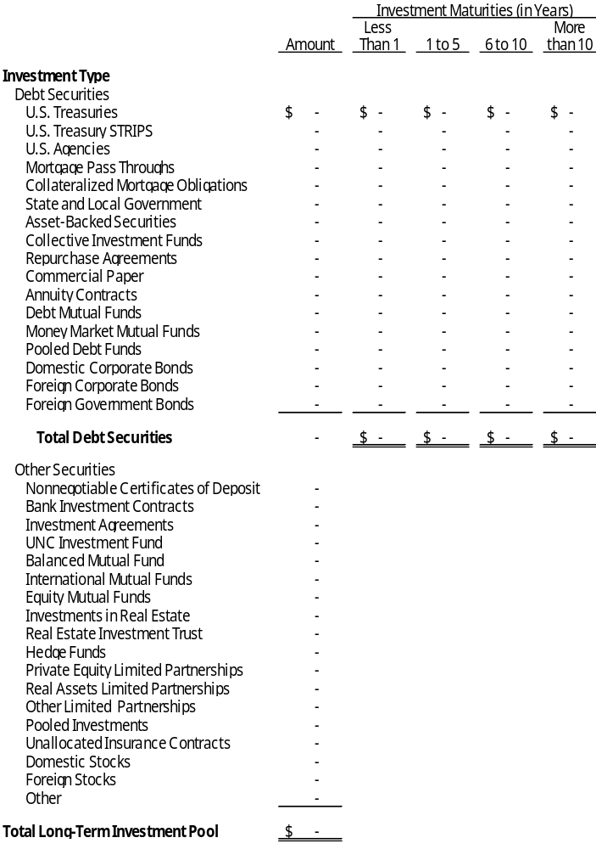
Certificates of deposit reported as investments are also a component of the deposit totals reported in the deposits section of this note. [Omit if not applicable.]
In addition to the interest rate risk disclosed above, the Long-Term Investment Pool portfolio includes investments highly sensitive to interest rate changes. [Describe - see paragraph 155 and 157 (examples listed were asset-backed securities) of GASB Codification Section I50 and Illustration 7 in GASB 40. Illustration 7 includes CMO’s, Inverse Variable-Rate Notes, and Variable-Coupon Note with Multiplier as examples of investments highly sensitive to interest rate changes.]
At June 30, 2026, investments in the Long-Term Investment Pool had the following credit quality distribution for securities with credit exposure: [Modify as necessary - disclose only lowest rating.]
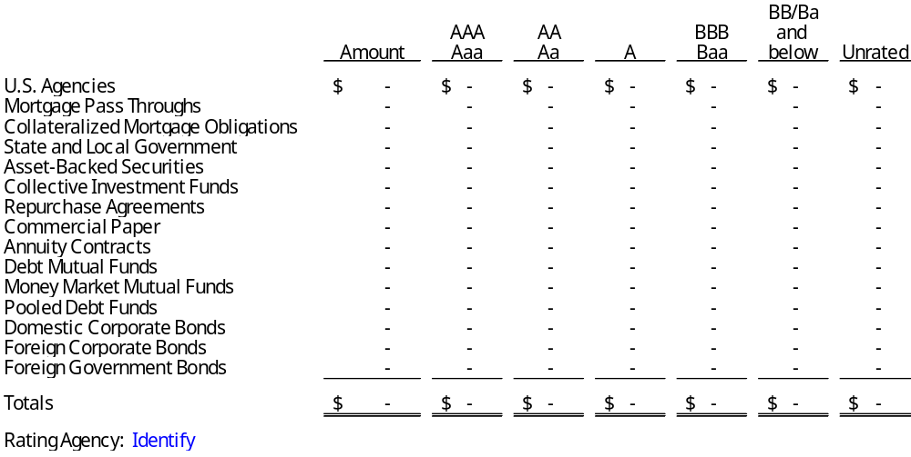
At June 30, 2026, investments in the Long-Term Investment Pool were exposed to custodial credit risk as follows: [Modify as necessary.]
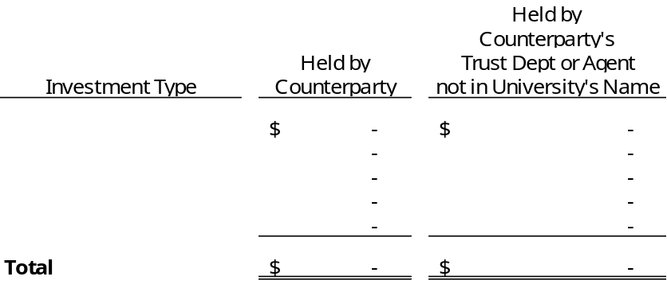
Concentration of Credit Risk: The Board of Trustees of the Endowment Fund places no limit on the amount the Board may invest in any one issuer. More than 5% of the Long-Term Investment Pool investments are in _______ and _______. These investments are ___% and ___%, respectively, of the Long-Term Investment Pool’s total investments. [Modify as necessary.]
Foreign Currency Risk: [Definition above assumes no policy. If policy, substitute wording similar to below - See GASB 40 illustration for further information. If no policy, eliminate first two sentences.] The Board of Trustees of the Endowment Fund’s investment policy permits it to invest up to ___% in foreign currency - ______. The Long-Term Investment Pool’s current position is ___%. Additionally, the Long-Term Investment Pool recognized an aggregate foreign currency transaction [gain/loss] of $_______ for the fiscal year ended June 30, 2026. Transaction gains or losses result from a change in exchange rates between the U.S. Dollar and the currency in which a foreign currency transaction is denominated.
At June 30, 2026, the Long-Term Investment Pool’s exposure to foreign currency risk is as follows:
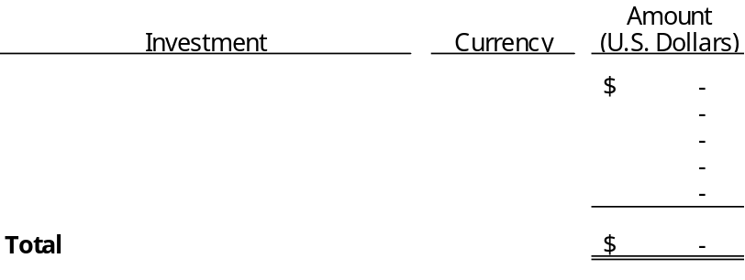
Investment Derivatives: At June 30, 2026, the Long-Term Investment Pool included $_________ of investment derivatives. Disclosures are provided for these investments in Note XX, Derivative Instruments. [Modify as necessary. Omit if not applicable.]
External Investment Pool - The External Investment Pool sponsored by the University was established in [date]. The Pool is utilized to manage the investments for charitable, nonprofit organizations, associations, trusts, endowments, and funds that are organized and operated primarily to support the University. Endowment funds [and other entities], which are component units included in the University’s reporting entity, __________ and __________ represent the Pool’s internal participants. Other affiliated organizations not included in the University’s reporting entity represent the Pool’s external participants. Fund ownership of the Pool is measured using the ________ method. Under this method, each participating fund’s investment balance is determined based on [explain basis for distribution]. The external portion of the Pool is presented in the accompanying fiduciary fund financial statements. [Modify as necessary]
The External Investment Pool is not registered with the SEC and is not subject to any formal oversight other than that provided by the Board of Directors. The Board is responsible for adopting investment objectives and policies, for hiring investment advisors, and for monitoring policy implementation and investment performance. The Board has chosen not to make individual security selection decisions. The Board’s primary role is to oversee the allocation of the Pool’s portfolio among the asset classes, investment vehicles, and investment managers.
_____________ is the custodian for the Pool and provides the University with monthly statements defining income and valuation, which is then allocated among the fund’s participants. There are no involuntary participants in the Pool. The University has not provided or obtained any legally binding guarantees during the period to support the value for the Pool’s investments. (The annual financial report for the External Investment Pool may be obtained from the University Controller’s Office, [provide address], or by calling [provide telephone number].) [Modify as necessary.]
The following tables in this section present the University’s External Investment Pool in total, including both proprietary and fiduciary funds. See Note 2C below for further details regarding investments by fund type within the External Investment Pool.
The following table presents investments by type and investments subject to interest rate risk at June 30, 2026, for the External Investment Pool. [Modify as necessary. See GASB 40 for illustration if policy in place to limit investment maturities. Note to Preparer: If dissimilar investments are grouped into a single investment type, be sure to break out the investment types further as necessary to meet the requirements of GASB Statements 3 and 40. Refer to GASB Codification Section I50 and the GASB Comprehensive Implementation Guide for further guidance about grouping investments by investment types.]
External Investment Pool

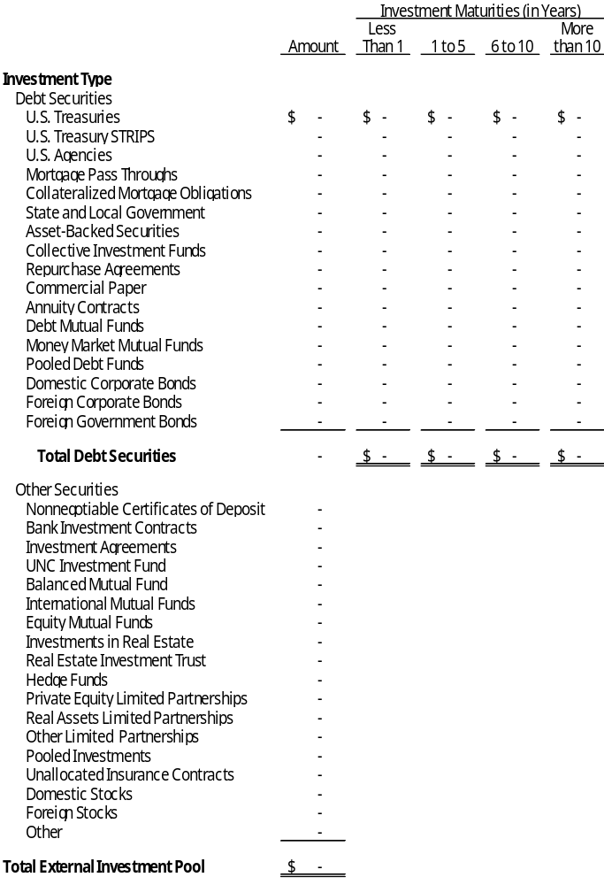
Certificates of deposit reported as investments are also a component of the deposit totals reported in the deposits section of this note. [Omit if not applicable.]
In addition to the interest rate risk disclosed above, the External Investment Pool portfolio includes investments highly sensitive to interest rate changes. [Describe - see paragraph 155 and 157 (examples listed were asset-backed securities) of GASB Codification Section I50 and Illustration 7 in GASB 40. Illustration 7 includes CMO’s, Inverse Variable-Rate Notes, and Variable-Coupon Note with Multiplier as examples of investments highly sensitive to interest rate changes.]
At June 30, 2026, investments in the External Investment Pool had the following credit quality distribution for securities with credit exposure: [Modify as necessary - disclose only lowest rating.]
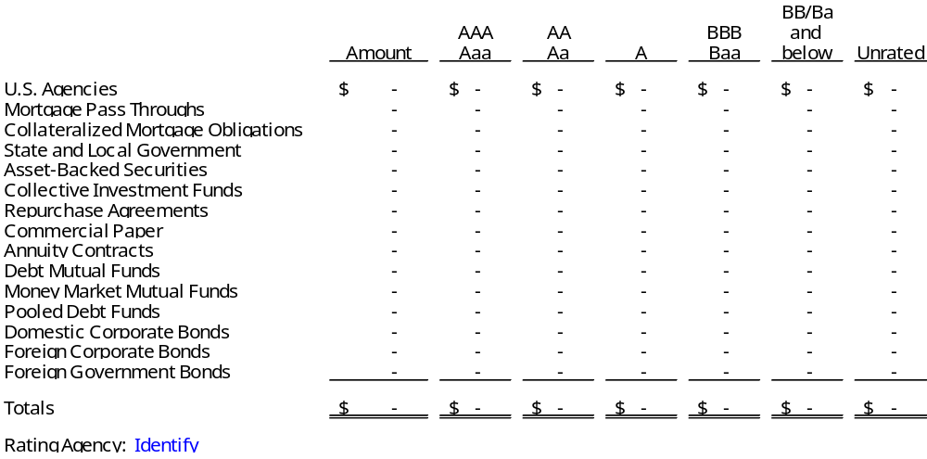
At June 30, 2026, the University’s investments in the External Investment Pool were exposed to custodial credit risk as follows: [Modify as necessary.]
Concentration of Credit Risk: The External Investment Pool Board places no limit on the amount the Board may invest in any one issuer. More than 5% of the External Investment Pool investments are in _______ and _______. These investments are ___% and ___%, respectively, of the External Investment Pool’s total investments. [Modify as necessary.]
Foreign Currency Risk: [Definition above assumes no policy. If policy, substitute wording similar to below - See GASB 40 illustration for further information. If no policy, eliminate first two sentences.] The External Investment Pool Board’s investment policy permits it to invest up to ___% in foreign currency - ______. The External Investment Pool’s current position is ___%. Additionally, the External Investment Pool recognized an aggregate foreign currency transaction [gain/loss] of $_______ for the fiscal year ended June 30, 2026. Transaction gains or losses result from a change in exchange rates between the U.S. Dollar and the currency in which a foreign currency transaction is denominated.
At June 30, 2026, the External Investment Pool’s exposure to foreign currency risk is as follows:
[If a governmental external investment pool is sponsored by the University and IT DOES PUBLISH A SEPARATE ANNUAL FINANCIAL REPORT FOR THE POOL, add the required GASB Codification Section I50 disclosures. The following is an example - placement of this portion of the note is dependent on its applicability.]
Separate financial statements for the Investment Fund may be obtained from the University Controller’s Office, [provide address], or by calling [provide telephone number].
[If a governmental external investment pool is sponsored by the University and IT DOES NOT PUBLISH A SEPARATE ANNUAL FINANCIAL REPORT FOR THE POOL, add the required GASB Codification Section I50 disclosures. The following are examples - placement of this portion of the note is dependent on its applicability.]
Since a separate annual financial report on the External Investment Pool has not been, and is not planned to be, issued, the following additional disclosures are being provided in the University’s financial statements.
The External Investment Pool’s Statement of Net Position and Statement of Operations and Changes in Net Position as of and for the period ended June 30, 2026, are as follows:
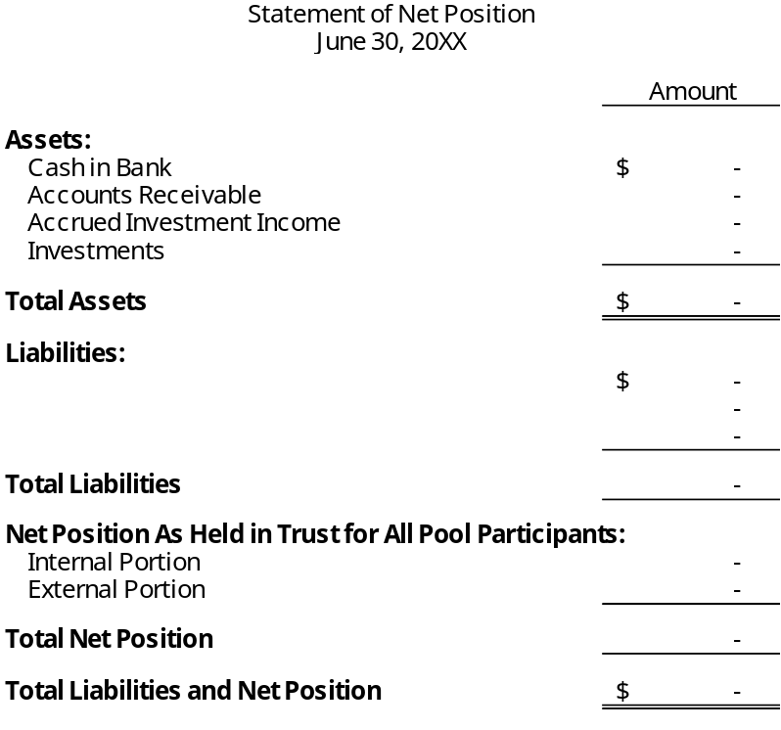
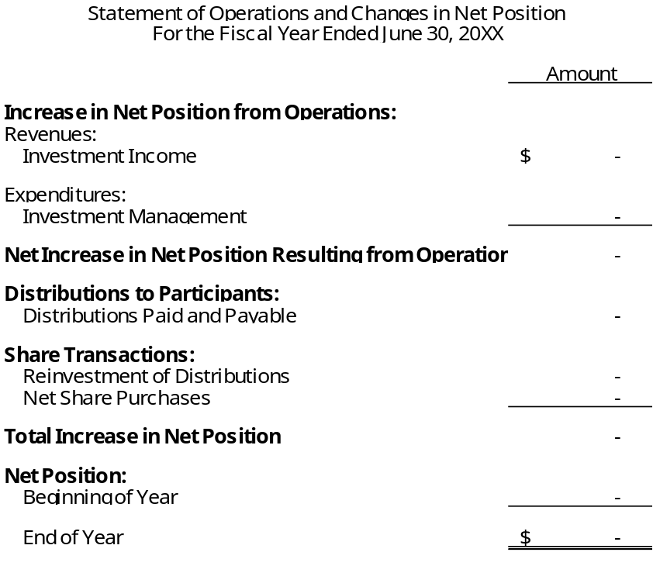
Investment Derivatives: At June 30, 2026, the External Investment Pool includes $_________ of investment derivatives. Disclosures are provided for these investments in Note XX Derivative Instruments. [Modify as necessary. Omit if not applicable.]
UNC Investment Fund, LLC - At June 30, 2026, the University’s investments include $________, which represents the University’s equity position in the UNC Investment Fund, LLC (UNC Investment Fund). The UNC Investment Fund is an external investment pool that is not registered with the Securities and Exchange Commission, does not have a credit rating, and is not subject to any regulatory oversight. Investment risks associated with the UNC Investment Fund are included in audited financial statements of the UNC Investment Fund, LLC which may be obtained from UNC Management Company, Inc., 1400 Environ Way, Chapel Hill, NC 27517. [Omit if not applicable.]
Non-Pooled Investments - The following table presents investments by type and investments subject to interest rate risk at June 30, 2026, for the University’s non-pooled investments. [Modify as necessary. Note to Preparer: If dissimilar investments are grouped into a single investment type, be sure to break out the investment types further as necessary to meet the requirements of GASB Statements 3 and 40. Refer to GASB Codification Section I50 and the GASB Comprehensive Implementation Guide for further guidance about grouping investments by investment types.]
Non-Pooled Investments

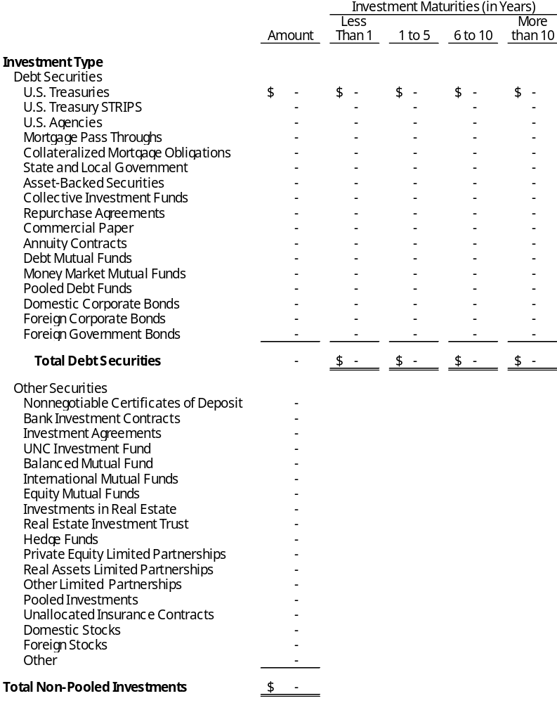
Certificates of deposit reported as investments are also a component of the deposit totals reported in the deposits section of this note. [Omit if not applicable.]
In addition to the interest rate risk disclosed above, the University’s investments include investments highly sensitive to interest rate changes. [Describe - see paragraph 155 and 157 (examples listed were asset-backed securities) of GASB Codification Section I50 and Illustration 7 in GASB 40. Illustration 7 includes CMO’s, Inverse Variable-Rate Notes, and Variable-Coupon Note with Multiplier as examples of investments highly sensitive to interest rate changes.]
At June 30, 2026, the University’s non-pooled investments had the following credit quality distribution for securities with credit exposure: [Modify as necessary - disclose only lowest rating.]
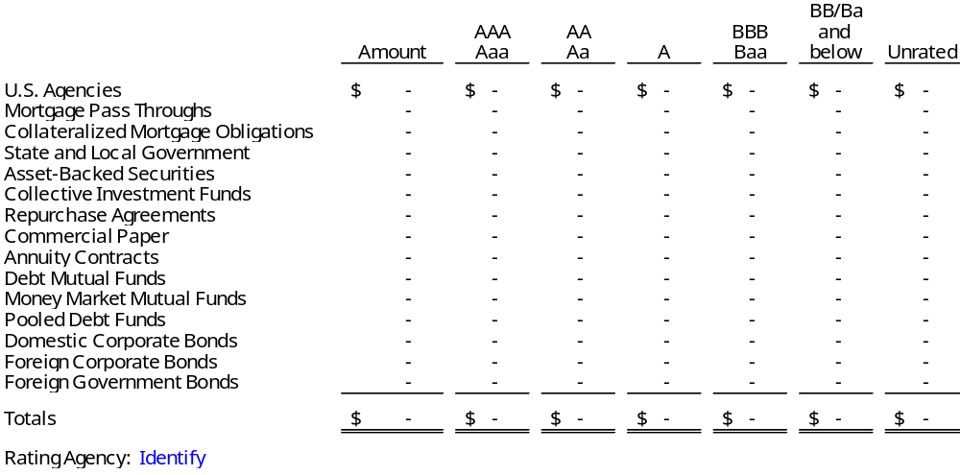
At June 30, 2026, the University’s non-pooled investments were exposed to custodial credit risk as follows: [Modify as necessary.]
Concentration of Credit Risk: The University places no limit on the amount that may be invested in any one issuer. More than 5% of the investments are in _______ and _______. These investments are ___% and ___%, respectively, of the University’s total investments. [Modify as necessary.]
Foreign Currency Risk: [Definition above assumes no policy. If policy, substitute wording similar to below - See GASB 40 illustration for further information. If no policy, eliminate first two sentences.] The University’s investment policy permits it to invest up to ___% in foreign currency - ______. The University’s current position is ___%. Additionally, the University recognized an aggregate foreign currency transaction [gain/loss] of $_______ for the fiscal year ended June 30, 2026. Transaction gains or losses result from a change in exchange rates between the U.S. Dollar and the currency in which a foreign currency transaction is denominated.
At June 30, 2026, the University’s exposure to foreign currency risk is as follows:
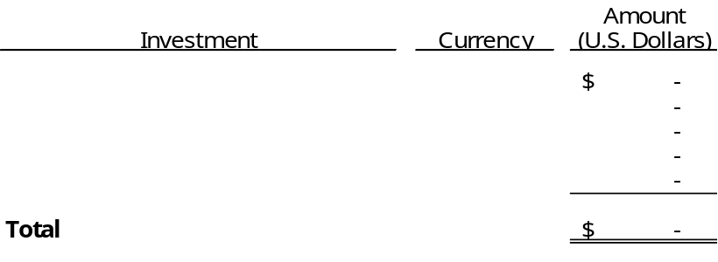
Investment Derivatives: At June 30, 2026, non-pooled investments include $_________ of investment derivatives. Disclosures are provided for these investments in Note XX, Derivative Instruments. [Modify as necessary. Omit if not applicable.]
Total Investments - The following table presents the total investments at June 30, 2026:

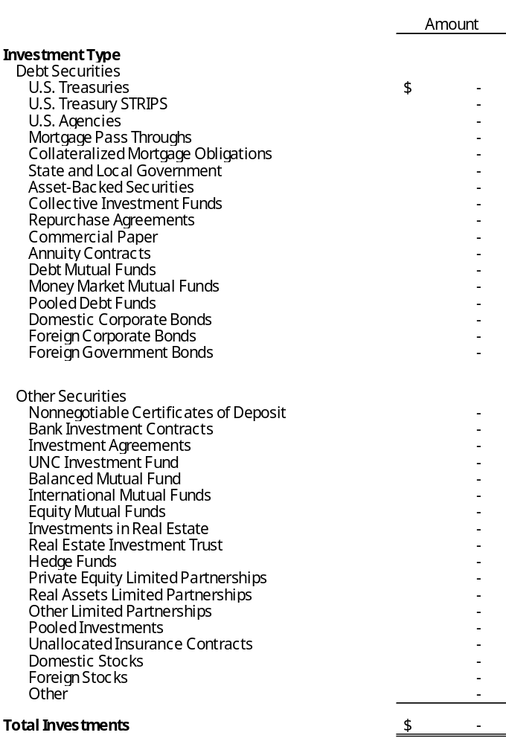
Total investments include $_______________ held in the _____________ Fund for component units that are discretely presented in the accompanying financial statements.
[For discretely presented component units with material investments not invested with the University - disclosure may be required. See GASB Codification I50 paragraph 139 for further guidance]
Component Unit(s) - Investments of the University’s discretely presented component unit(s), [the Foundation and Investment Fund,] are subject to and restricted by Chapter 36E of the North Carolina General Statutes, otherwise known as the Uniform Prudent Management of Institutional Funds Act (UPMIFA), and any requirements placed on them by contract or donor agreements. Because the [Foundation] report(s) under the FASB reporting model, disclosures of the various investment risks are not required. The following is an analysis of investments by type: [Provide disclosures as necessary based on audit report for foundation.]
C. Reconciliation of Deposits and Investments - A reconciliation of deposits and investments for the University as of June 30, 2026, is as follows: [GASB Codification 2300.904 includes a sample reconciliation of the total deposits and investments balances to the Government-Wide Statement of Net Position and the Fiduciary Statement of Net Position. Below has been modified to reconcile the total amount of deposits and investments disclosed in part B and C above to the financial statements. If no fiduciary statements are presented this reconciliation is optional.]
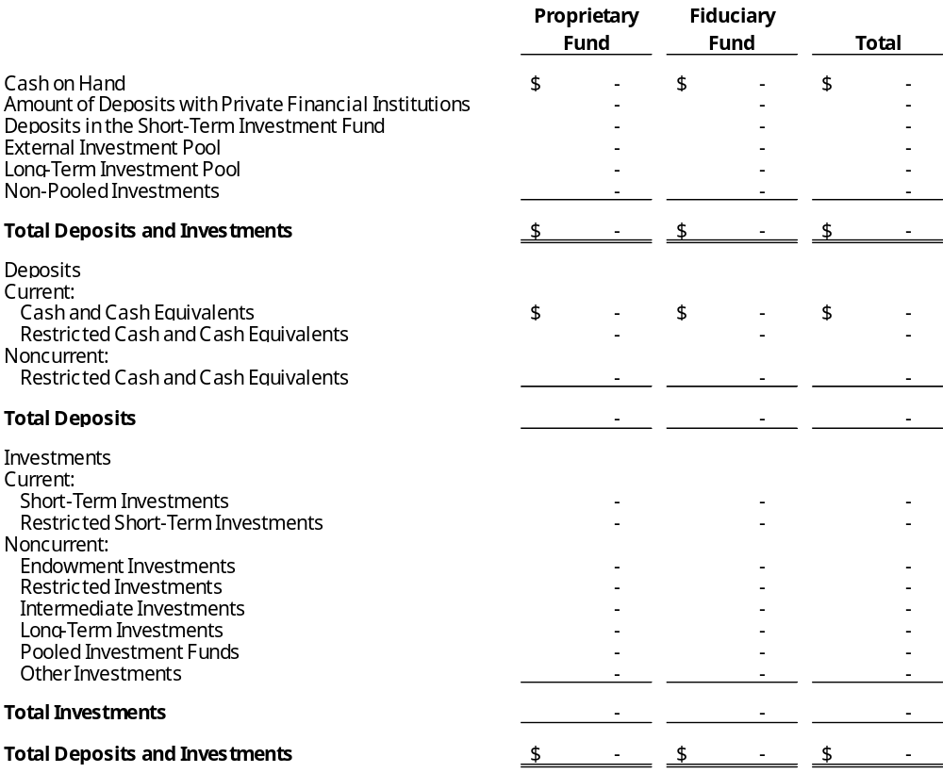
[Note to Preparer: If an external investment pool meets the criteria in GASB 79 and measures all of its investments at amortized cost, the pool’s participants also should measure their investments in that external investment pool at amortized cost for financial reporting purposes. GASB 79 ¶42 establishes additional note disclosure requirements for qualifying external investment pools that measure all of its investments at amortized cost and for governments that participate in those pools. Information about any limitations or restrictions on participant withdrawals should be disclosed. These disclosures are in addition to existing disclosure requirements for external investment pools.]

Note 3 - Fair Value Measurements
[If the University does not have discretely presented component units with fair value disclosures, delete the “University” bold below. See GASB Codification 2300.105]
University - To the extent available, the University’s investments [and derivatives] are recorded at fair value as of June 30, 2026. GASB Statement No. 72, Fair Value Measurement and Application, defines fair value as the price that would be received to sell an asset or paid to transfer a liability in an orderly transaction between market participants at the measurement date. This statement establishes a hierarchy of valuation inputs based on the extent to which the inputs are observable in the marketplace. Inputs are used in applying the various valuation techniques and take into account the assumptions that market participants use to make valuation decisions. Inputs may include price information, credit data, interest and yield curve data, and other factors specific to the financial instrument. Observable inputs reflect market data obtained from independent sources. In contrast, unobservable inputs reflect the entity’s assumptions about how market participants would value the financial instrument. Valuation techniques should maximize the use of observable inputs to the extent available.
A financial instrument’s level within the fair value hierarchy is based on the lowest level of any input that is significant to the fair value measurement. The following describes the hierarchy of inputs used to measure fair value and the primary valuation methodologies used for financial instruments measured at fair value on a recurring basis:
Level 1 Investments whose values are based on quoted prices (unadjusted) for identical assets (or liabilities) in active markets that a government can access at the measurement date.
Level 2 Investments with inputs – other than quoted prices included within Level 1 – that are observable for an asset (or liability), either directly or indirectly.
Level 3 Investments classified as Level 3 have unobservable inputs for an asset (or liability) and may require a degree of professional judgment.
[Note to Preparer: Remove reference to liabilities above if the University has no liabilities that are measured at fair value]
The following table summarizes the University’s proprietary and fiduciary fund investments, including deposits in the Short-Term Investment Fund, within the fair value hierarchy at June 30, 2026:
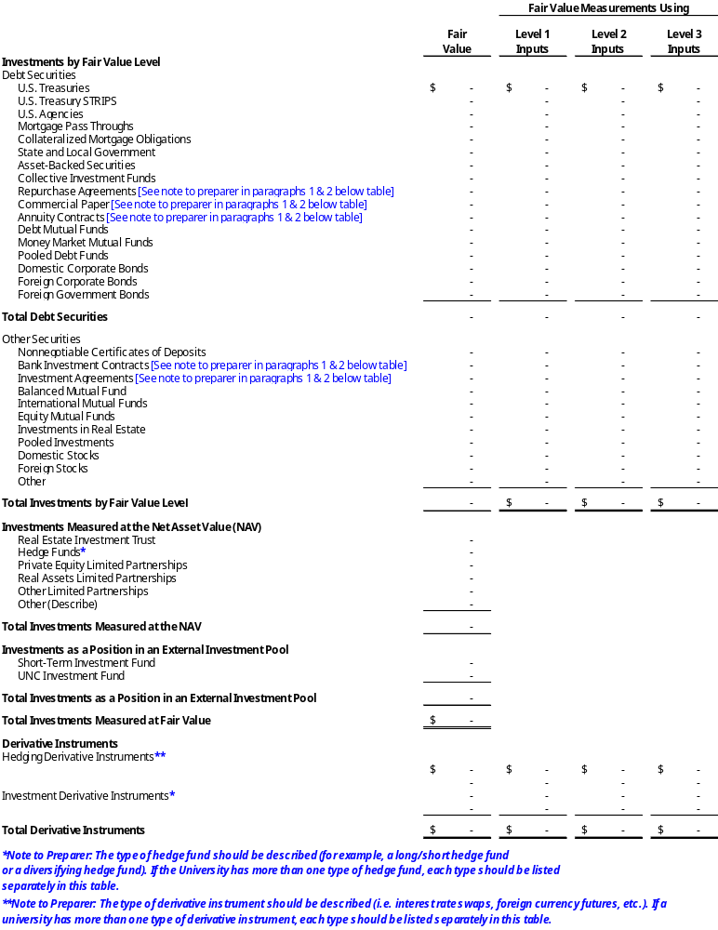
Note to Preparer: See GASB Codification I50.109 through 126 for exceptions to fair value reporting.
Note to Preparer: See GASB Codification 3100.162 for the requirements of disclosure for recurring and nonrecurring assets and liabilities.
Short-Term Investment Fund - At year-end, the University’s investments held in the STIF were valued at $_____ [Note: only include the preceding sentence if the only investments of the Universities are STIF and UNC Investment Fund. Remove FV table if that is all that is disclosed]. Ownership interests of the STIF are determined on a fair market valuation basis as of fiscal year end in accordance with the STIF operating procedures. Valuation of the underlying assets is performed by the custodian. Pool investments are measured at fair value in accordance with GASB Statement No. 72. The University’s position in the pool is measured and reported at fair value and the STIF is not required to be categorized within the fair value hierarchy.
UNC Investment Fund - At year-end, the University’s investments held in the UNC Investment Fund were valued at $_____ [Note: only include the preceding sentence if the only investments of the Universities are STIF and UNC Investment Fund. Remove FV table if that is all that is disclosed]. Ownership interests of the UNC Investment Fund are determined on a market unit valuation basis each month and in accordance with the UNC Investment Fund’s operating procedures. Valuation of the underlying assets is performed by the custodian. Pool investments are measured at fair value in accordance with GASB Statement No. 72. The University’s position in the pool is measured and reported at fair value and the UNC Investment Fund is not required to be categorized within the fair value hierarchy.
Debt and Equity Securities - [Example – GASB Codification 3100.901, Illustration 5, Example 2: Debt and equity securities classified in Level 1 of the fair value hierarchy are valued using prices quoted in active markets for those securities. Debt securities classified in Level 2 of the fair value hierarchy are valued using a matrix pricing technique. Matrix pricing is used to value securities based on the securities’ relationship to benchmark quoted prices. Commercial and residential mortgage-backed securities classified in Level 3 are valued using discounted cash flow techniques. Collateralized debt obligations classified in Level 3 are valued using consensus pricing. Modify as necessary.]
[Note to Preparer: the paragraph above is example language and should be modified as necessary to describe the valuation technique(s) applied to the university’s specific debt and equity securities classified in Levels 1, 2 and 3. If a level includes securities that are not all valued using the same technique, a description of each of the securities and its respective valuation technique should be included. See last two sentences of the paragraph above for example.]
Disclosures for Derivative Instruments:
Derivative Instruments - [Example – GASB 3100.901, Illustration 5, Example 2: Derivative instruments classified as Level 2 of the fair value hierarchy are valued using a market approach that considers benchmark interest rates and foreign exchange rates. Modify as necessary.]
[Note to Preparer: The paragraph above is example language and should be modified as necessary to describe the valuation technique(s) applied to the University’s specific derivatives classified in Levels 1, 2 and 3. If a level includes derivatives that are not all valued using the same technique, a description of each of the derivatives and its respective valuation technique should be included.]
The following table presents the valuation of investments measured at the Net Asset Value (NAV) per share (or its equivalent) at June 30, 2026: [Modify as necessary.]
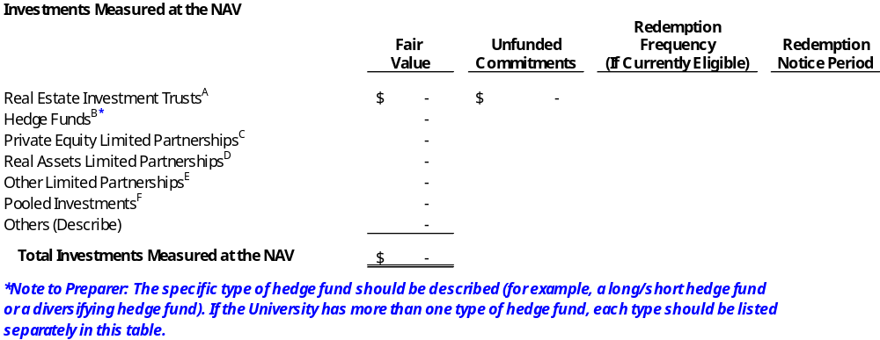
Note to Preparer: Per GASB Codification 3100.163 specific disclosures regarding each type of investment measured at the NAV (or its equivalent) are required. Tickmarks A-E in the table above should each be discussed in separate paragraphs. See GASB Codification 3100.163 for the specific requirements to be disclosed.
A. Real Estate Investment Trusts - [Modify as necessary.]
B. Hedge Funds - [Example language for an equity long/short hedge fund in GASB Codification 3100.901, Illustration 4, Example 2. Modify as necessary.]
C. Private Equity Limited Partnerships - [Modify as necessary.]
D. Real Assets Limited Partnerships - [Modify as necessary.]
E. Other Limited Partnerships - [Modify as necessary.]
F. Pooled Investments - [Modify as necessary.]
Component Unit(s) - [If the University has discretely presented component units with fair value disclosures, provide disclosures as necessary based on the audit report(s) for those component units]

Note 4 - Endowment Investments
Investments of the University’s endowment funds are pooled, unless required to be separately invested by the donor. If a donor has not provided specific instructions, state law permits the Board of Trustees to authorize for expenditure the net appreciation, realized and unrealized, of the investments of the endowment funds. Under Chapter 36E of the North Carolina General Statutes, otherwise known as the Uniform Prudent Management of Institutional Funds Act (UPMIFA), the Board may also appropriate expenditures from eligible nonexpendable balances if deemed prudent and necessary to meet program outcomes and for which such spending is not specifically prohibited by the donor agreements. [However, a majority of the University’s endowment donor agreements prohibit spending of nonexpendable balances and therefore the related nonexpendable balances are not eligible for expenditure. Modify as necessary.] [During the year, the Board did not appropriate expenditures from eligible nonexpendable endowment funds. – or - During the year, the Board appropriated $________ in expenditures from eligible nonexpendable endowment funds.]
[For universities using the total return concept an example follows.]
Investment return of the University’s endowment funds is predicated on the total return concept (yield plus appreciation). [GASB Codification 2300.123 requires the disclosure of the University’s policy for authorizing and spending investment income. Insert here.] At June 30, 2026, net appreciation of $__________ was available to be spent, of which $____________ was classified in net position as [classification (i.e. restricted: expendable: scholarships, research, instructions, and other)] as it is restricted for specific purposes. The remaining portion of net appreciation available to be spent is classified as unrestricted net position. [Modify as Necessary.]
OR
[For Universities not using the total return concept an example follows.]
Investment return of the University’s endowment funds is predicated under classical trust doctrines. Unless the donor has stipulated otherwise, capital gains and losses are accounted for as part of the endowment principal and are not available for expenditure. [GASB Codification 2300.123 requires the disclosure of the University’s policy for authorizing and spending investment income. Inset here.] At June 30, 2026, net appreciation of $__________ was available to be spent, of which $____________ was classified in net position as [classification (i.e. restricted: expendable: scholarships, research, instructions, and other)] as it is restricted for specific purposes. The remaining portion of net appreciation available to be spent is classified as unrestricted net position. [Modify as Necessary.]
During the current year, the University incurred investment losses that exceeded the related endowment’s available accumulated income and net appreciation. These losses resulted in a reduction to the specific nonexpendable endowment balance. At June 30, 2026 the amount of investment losses reported against the nonexpendable endowment balances was $_________. [Modify as necessary if applicable to fiduciary funds]

Note 5 - Receivables
Receivables for the proprietary fund at June 30, 2026, were as follows: [Note to preparer: Receivables related to the construction/acquisition of capital assets may be classified as noncurrent unless a related current liability has been recorded (i.e. receivable to be used for payment of payable classified as a current liability). See GASB Codification 2200.176-177 and .744 for additional guidance.]
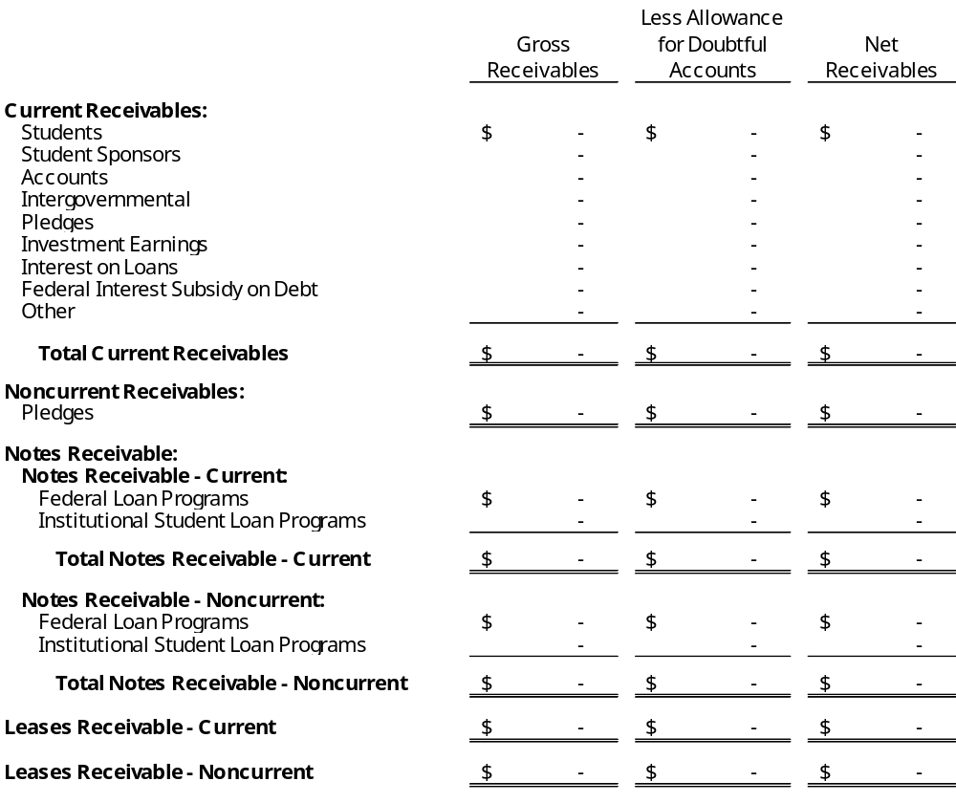
[Note to Preparer: If there is no allowance related to leases, the lease receivable can be omitted from disclosure.]
Receivables for the fiduciary fund(s) at June 30, 2026, were as follows: [Omit if not presenting fiduciary funds or if fiduciary receivables are not aggregated on Exh. B-1]
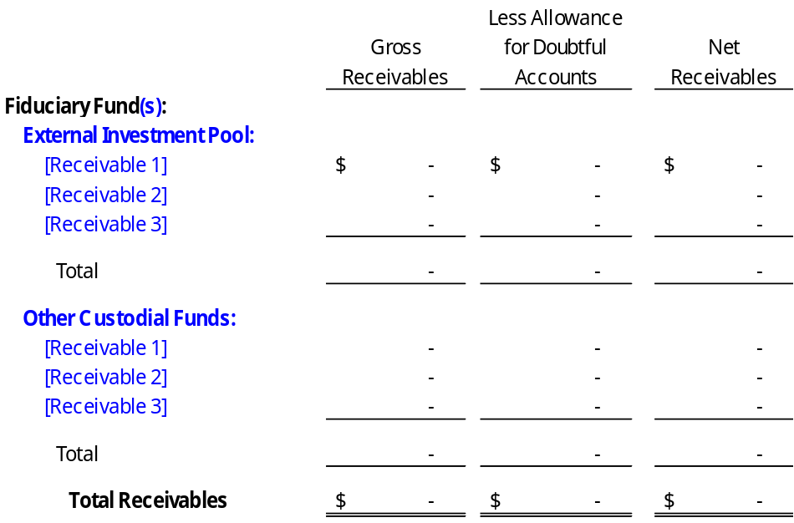

Note 6 - Capital Assets
A summary of changes in the capital assets for the year ended June 30, 2026, is presented as follows: [See below table for disclosures related to impairment of capital assets insurance recoveries and capital assets held for sale.]
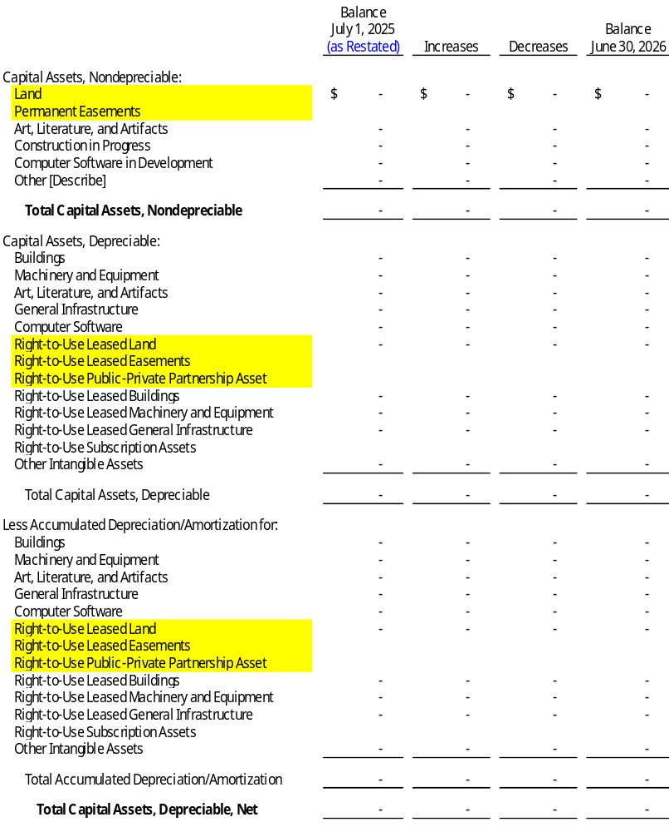
As of June 30, 2026, the total amount of right-to-use leased and subscription assets was $________ and $________, and the related accumulated amortization was $_________ and $________, respectively. [Note to Preparer: This sentence can be removed if reporting only one type of RTU leased assets]
[Replace Other [Describe] with the name of any other major category of intangible assets capitalized by the University. See GASB 51 for further guidance.]
[Note to preparer: Disclosure of assets pledged as collateral for debt now included in long-term liabilities disclosure with other GASB 88 requirements.]
The carrying amount of impaired capital assets idle at year-end is $_______ for buildings and $_______ for machinery and equipment.
Supplies and services expense includes an impairment loss of $_______ due to __________, which is net of an insurance recovery of $_________. In addition, nonoperating revenues include an insurance recovery of ______ related to prior year impairments. [See GASB Statement No. 42 for additional information on impaired assets, including insurance recoveries] [Note to Preparer: If the University has significant assets that were recorded at acquisition value, explain the methods that were used to determine the asset’s value.]
[Note to Preparer: If the University has significant capital assets held for sale include for each major asset class: 1) Description of the assets to be sold (for example: land, building equipment, etc.); 2) Ending balance of the capital asset held for sale. The amount of historical cost and accumulated depreciation disclosed separately by major asset class; 3) Carrying amount of debt for which the capital assets held for sale are pledged as collateral for each major class of asset. Example disclosure follows.]
The University has buildings that are expected to be sold within the next reporting period. The historical cost of the buildings held for sale is $_________ with accumulated depreciation of $_________________ as of June 30, 2026. The buildings held for sale are pledged as collateral for debt with an outstanding balance of $________________ as of June 30, 2026.

Note 7 - Public-Private Partnership For [describe asset transferred – revise title as necessary]
[Note to Preparer: This disclosure applies to institutions involved in public-private, public-public, or availability payment arrangements (including service concession arrangements). See GASB Statement No. 94 for reporting and disclosure requirements, including illustrative examples.]

Note 8 - Accounts Payable and Accrued Liabilities
Accounts payable and accrued liabilities at June 30, 2026, were as follows:
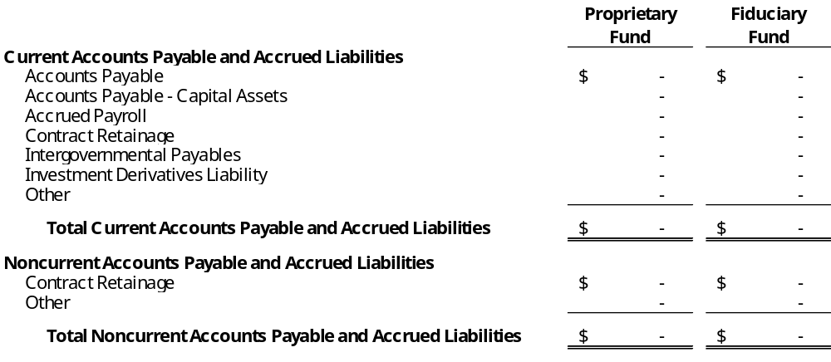
[Notes to Preparer: Per GASB Codification D40.115 Investment Derivatives will only be included in Accounts Payable and Accrued Liabilities if they have a negative market value. Be sure to evaluate the Investment Derivatives Liability to determine if there is a noncurrent portion. If it is noncurrent, modify this note and be sure to disclose the noncurrent accounts payable and accrued liabilities amount on the face of the Statement of Net Position.]

Note 9 - Reverse Repurchase Agreements
[If the University has entered into any reverse repurchase agreements during the year, provide information required by GASB - see GASB Codification section I55.106 113. The following is an example of this disclosure - see example in Codification at I50.901 for additional example - this disclosure will require modification for your specific circumstances.]
Under the University’s authority to purchase and sell securities, it has entered into fixed-coupon reverse repurchase agreements; that is, a sale of securities with a simultaneous agreement to repurchase them in the future at the same price plus a contract rate of interest. The value of the securities underlying reverse repurchase agreements normally exceeds the cash received, providing the dealers a margin against a decline in value of the securities. If the dealers default on their obligations to resell these securities to the University or provide securities or cash of equal value, the University would suffer an economic loss equal to the difference between the value plus accrued interest of the underlying securities and the agreement obligation, including accrued interest. This credit exposure at year-end was $_________.
All sales of investments under reverse repurchase agreements are for fixed terms. In investing the proceeds of reverse repurchase agreements, the University’s practice is for the term to maturity of the investment to be the same as the term of the reverse repurchase agreement. The University’s investments in the underlying securities and the securities purchased with proceeds from the reverse repurchase agreements are in accordance with the statutory requirements as noted. The interest earnings and interest cost arising from reverse repurchase agreement transactions are reported at gross amounts on the accompanying financial statements.

Note 10 - Short-Term Debt - [Type]
[Describe the short-term debt. Example: The University uses a revolving line of credit to finance _______________. This line of credit was necessary to __________________. Activity must be described even if no outstanding balance at year-end - see GASB 38, paragraph 12.)]
[See GASB Statement 62 paragraph 36-40 for classification criteria regarding bond anticipation notes.]
Short-term debt activity for the year ended June 30, 2026, was as follows:
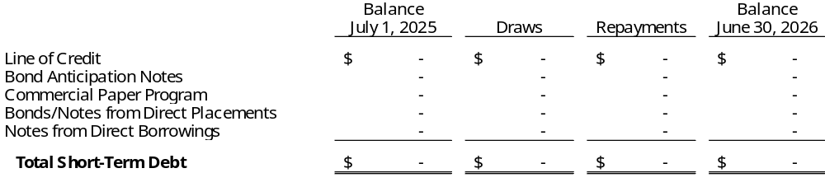
Unused Line(s) of Credit - [If no current year activity (draws/repayments) or ending balance, remove table and include only this paragraph] The University has a line of credit agreement with [financing entity] for financing of an amount up to $________. This line was unused during the year ended June 30, 2026 and has no outstanding balance. [Omit if not applicable. Modify as necessary]
[GASB 88 also requires the following disclosures if applicable to short-term debt agreements: Assets pledged as collateral for short-term debt, or terms specified in short-term debt agreements related to significant (1) events of default with finance-related consequences, (2) termination events with finance-related consequences, and (3) subjective acceleration clauses]

Note 11 - Long-Term Liabilities
University Note 1: If the University has discretely presented component units with material long-term liabilities, keep this caption and complete component unit section at end of this note. If no material long-term liabilities in the discretely presented component units - delete this University caption and the component unit caption below.
Note 2: ‘Special Indebtedness’ below includes Certificates of Participation (COPs) and Limited Obligation Bonds (LOBs). If your institution only has either COPs or LOBs, you may elect to change references to ‘special indebtedness’ in this note to specify which one. If your entity has both, aggregate them under the term ‘Special Indebtedness’ as provided in this disclosure.
Note 3: Per GASB 88, direct placements are debt issuances with terms negotiated directly with the investor(s) and are not offered for public sale. Direct borrowings are those with terms directly negotiated with the lender. GASB 88 paragraph 6 requires that information related to direct placements and direct borrowings be separated from other debt in the notes to the financial statements.
A. Changes in Long-Term Liabilities - A summary of changes in the long-term liabilities for the year ended June 30, 2026, is presented as follows:
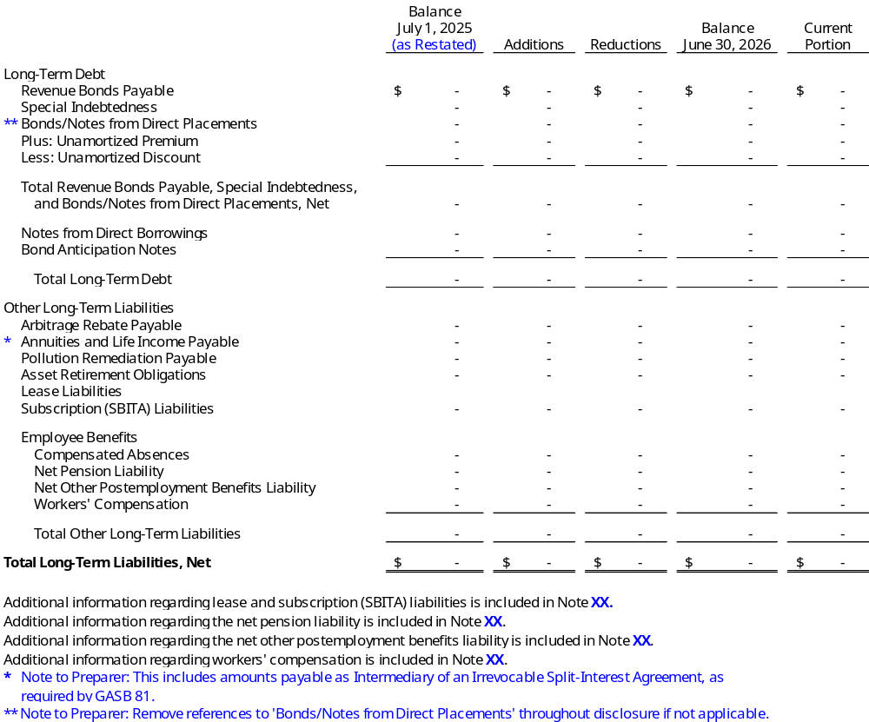

B. Revenue Bonds Payable, Special Indebtedness, and Bonds/Notes from Direct Placements - The University was indebted for revenue bonds payable, special indebtedness (which includes Certificates of Participation and Limited Obligation Bonds), and bonds/notes from direct placements for the purposes shown in the following table: [Note to preparer: For bonds with interest rate swaps, the synthetic rate should be disclosed below as the interest rate and it should have an asterisk next to it per the note to the financial statement reader at the bottom of the table, identifying it as the synthetic rate. For bonds with installments where each has a different rate (hence a range of interest rates must be disclosed) only include interest rates that will be paid in the future (end of the fiscal year forward) (for example, do not include rates for installments that have already been paid.)]
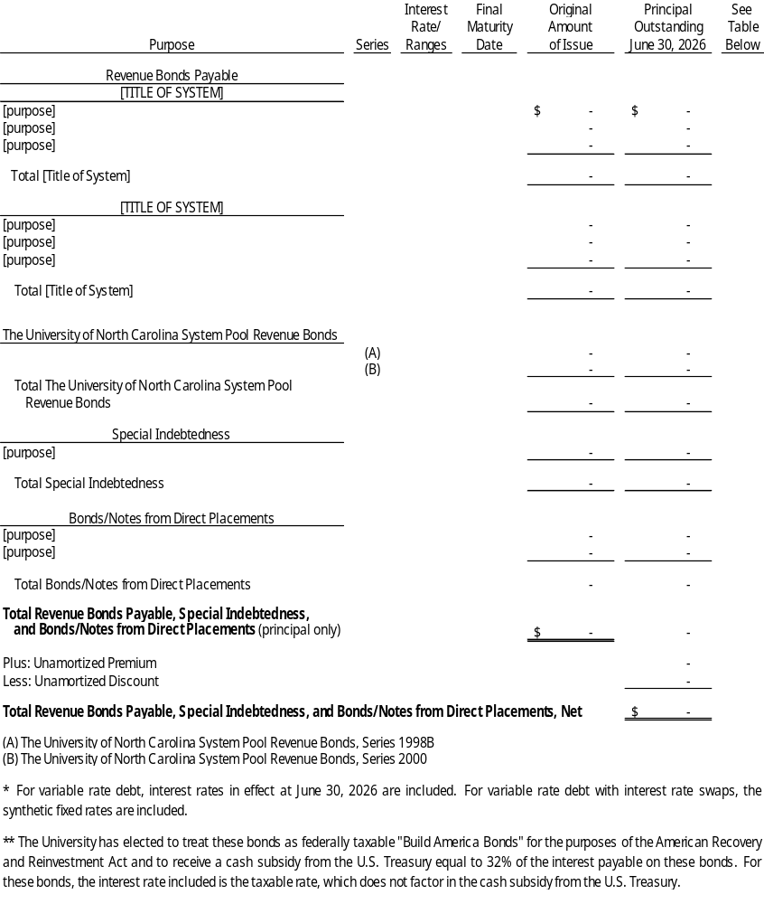
The University has pledged future revenues, net of specific operating expenses, to repay revenue bonds, special indebtedness, and bonds/notes from direct placements as shown in the table below: [Modify if no special indebtedness or direct placements. Note 1 to preparer: If single revenue stream is pledged for multiple issuances, may combine disclosure; i.e. housing revenues for multiple issues, list housing revenues as source and use multiple ref numbers from above to indicate combination. Note 2 to preparer: GASB 48 requires disclosure of percent of future revenues pledged, if estimable. A possible source of the estimate of future revenues is the official statement which may include an estimate of future revenues over the life of the debt. Note 3 to preparer: Evaluate Federal Interest Subsidy on Debt revenue to determine if it should be included in the following table.]
C. Notes from Direct Borrowings - The University was indebted for notes from direct borrowings for the purpose(s) shown in the following table:
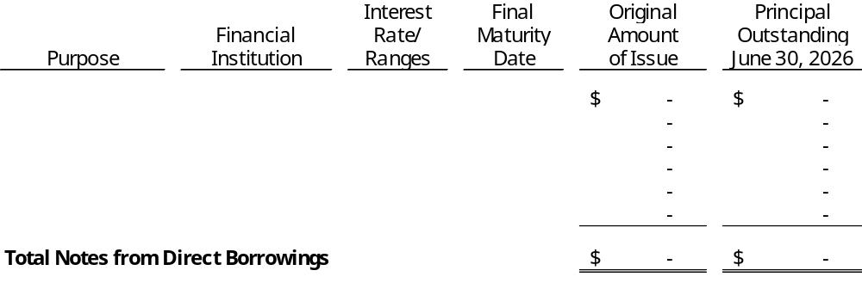
The University plans to refinance the notes maturing on [date] with other long-term financing.
[Report any long-term liabilities representing the University’s obligation to make payments under a Licensing Agreement (for commercially available software acquired through a licensing agreement requiring multi-year payments) in the above Notes Payable table.]
D. Annual Requirements - The annual requirements to pay principal and interest on the
long-term obligations at June 30, 2026, are as follows:
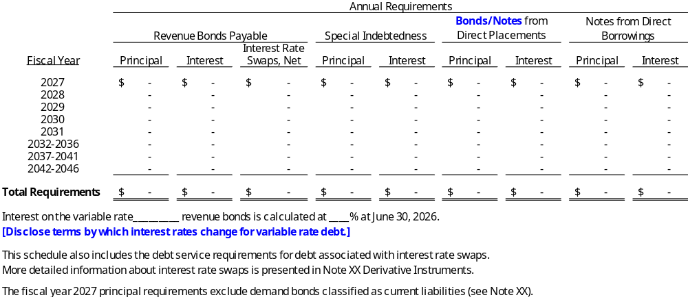
E. Debt Authorized but Unissued - At June 30, 2026, the University had $________ in authorized but unissued revenue bonds. [Modify as necessary.] [Note: If the authorized debt is issued at any point after the end of the fiscal year and disclosed as a subsequent event, remove this paragraph from the note.]
F. Demand Bonds - Included in bonds payable are several variable rate demand bond issues. Demand bonds are securities that contain a “put” feature that allows bondholders to demand payment before the maturity of the debt upon proper notice to the University’s remarketing or paying agents.
[See GASB COD – BAL SHT & OPER ST, Section D30: Demand Bonds for disclosure requirements.]
G. Terms of Debt Agreements - [Per GASB 88 paragraph 5(b)-(c), disclosure should include assets pledged as collateral for debt as well as terms specified in debt agreements related to significant (1) events of default with finance-related consequences, (2) termination events with finance-related consequences, and (3) subjective acceleration clauses.] The University’s debt agreements are subject to the following collateral requirements and terms with finance-related consequences: [Modify as necessary.]
Revenue Bonds Payable - [Describe assets pledged as collateral and significant terms. Similar terms can be referenced for multiple series, as applicable. Omit if not applicable.]
Special Indebtedness - [Describe assets pledged as collateral and significant terms. Similar terms can be referenced for multiple series, as applicable. Omit if not applicable.]
Bonds/Notes from Direct Placements - [Describe assets pledged as collateral and significant terms. Similar terms can be referenced for multiple series, as applicable. Omit if not applicable.]
Notes from Direct Borrowings - [Disclose the following for the University’s ESCO note:] The University has pledged the energy savings improvements installed in its buildings and other structures as collateral for the UNC System Guaranteed Energy Savings Installment Financing Agreement dated September 1, 2014. This agreement also contains provisions related to events of default and remedies. Significant to these provisions, an event of default occurs when: (1) the University fails to pay an installment payment when due, (2) an event of nonappropriation from the State occurs, (3) insurance coverage on the asset is not maintained, or (4) the University fails to perform any warranty, covenant, condition, or agreement within thirty days of receiving written notice by the lender or fails to diligently pursue corrective action for matters that cannot be reasonably corrected within thirty days.
Upon the occurrence of any event of default, the lender may, without any further demand or notice, declare the unpaid principal amount plus any accrued and unpaid interest be due and payable immediately. The lender may also exercise all remedies available by law or in the equity provided under the agreement, including sale of the secured assets, and apply the proceeds of any such sale to the amounts due after deducting all costs and expenses related to the recovery, repair, storage, and sale of the secured assets, including court costs and reasonable attorneys’ fees incurred.
[Describe assets pledged as collateral and significant terms for other notes from direct borrowings. Similar terms can be referenced for multiple borrowings, as applicable. Omit if not applicable.]
Bond Anticipation Notes - [Describe assets pledged as collateral and significant terms. Similar terms can be referenced for multiple notes, as applicable. Omit if not applicable.]
[Note to preparer: modify components above as necessary and add any additional debt components reported (e.g. capital appreciation bonds)]
H. Bond Defeasance - The University has extinguished long-term debt obligations by the issuance of new long-term debt instruments as follows:
[Example of a current refunding:]
On [date] the University issued $_______ in [Title of New Bond Issue] refunding bonds with an average interest rate of ___%. The bonds were issued for a current refunding of $______ of outstanding [Title of Old Bond Issue] bonds with an average interest rate of ____%. The refunding was undertaken to reduce total debt service payments by $______ over the next ___ years and resulted in an economic gain of $_______. The substitution of essentially risk-free monetary assets with monetary assets that are not essentially risk-free is not prohibited. [Note to Preparer: Universities should review trust or escrow agreements, bond indentures, etc. to determine if the substitution of risk-free monetary assets for in-substance defeasance transactions is prohibited. If substitution is prohibited, delete the last sentence in the paragraph above.]
[Example of a current year advance refunding.]
On [date] the University issued $_______ in [Title of New Bond Issue] refunding bonds with an average interest rate of ___%. The bonds were issued to advance refund $______ of outstanding [Title of Old Bond Issue] bonds with an average interest rate of ____%. The net proceeds of the refunding bonds [along with other resources] were used to purchase U.S. government securities. These securities were deposited into an irrevocable trust to provide for all future debt service payments on the refunded bonds. As a result, the refunded bonds are considered to be defeased and the liability has been removed from the University’s Statement of Net Position. The substitution of essentially risk-free monetary assets with monetary assets that are not essentially risk-free is not prohibited. [Note to Preparer: Universities should review trust or escrow agreements, bond indentures, etc. to determine if the substitution of risk-free monetary assets for in-substance defeasance transactions is prohibited. If substitution is prohibited, delete the previous sentence.] This advance refunding was undertaken to reduce total debt service payments by $_____ over the next ___years and resulted in an economic gain of $____. At June 30, 2026, the outstanding balance was $_______ for the defeased [Title of Old Issue] bonds.
Prior Year Defeasances - During prior years, the University defeased certain bonds by placing the proceeds of new bonds in an irrevocable trust to provide for all future debt service payments on the old bonds. Accordingly, the trust account assets and the liability for the defeased bonds are not included in the University’s financial statements. At June 30, 2026, the outstanding balance of prior year defeased bonds was $_________.
For certain prior year defeasances, the substitution of essentially risk-free monetary assets with monetary assets that are not essentially risk-free is not prohibited. At June 30, 2026, the outstanding balance of prior year defeased bonds for which substitution is not prohibited was $________. [Note to Preparer: Universities should review trust or escrow agreements, bond indentures, etc. to determine if the substitution of risk-free monetary assets for in-substance defeasance transactions is prohibited. Delete this paragraph if substitution is prohibited.]
[Note to Preparer: If the University defeased debt in the current year using only existing resources, or defeased debt in prior years using only existing resources, additional note disclosures are required. Refer to GASB ¶ 7-8 for guidance regarding the additional required disclosures.]
I. Bond Anticipation Notes - On [Date], the University entered into a loan agreement with [Lending Institution] for $________ to be repaid with bond proceeds received in [Date] as disclosed in Subsequent Event Note ___. [Provide a description of what the proceeds were used to finance].
[See GASB Statement 62 paragraph 36-40 for additional guidance.]
J. Annuities Payable - [Provide description of annuities payable, if applicable.]:
K. Pollution Remediation Payable - [See GASB 49, Accounting and Financial Reporting for Pollution Remediation Obligations. An example is provided as follows.] The University has recognized a pollution remediation liability for [describe the nature and source of liability]. The amount of the estimated liability is $__________. This estimate was calculated [describe the methods and assumptions used when calculating the estimated liability]. This liability is subject to potential changes due to [describe potential changes; for example, price increases or reductions, technology, or applicable laws or regulations]. The amount of the estimated recoveries for this estimated liability is $___________. [Omit if not applicable. Modify as necessary.]
The University has a pollution remediation liability that could not yet be recognized because it is not reasonably estimable. This liability is [provide a general description of the nature of the pollution remediation activities]. [Omit if not applicable. Modify as necessary.]
L. Asset Retirement Obligations - [See GASB 83 para. 27-29 for specific disclosure requirements. An example is provided as follows.] The University has recognized asset retirement obligations for [describe the nature and source of obligation(s). Should include information about the associated capital asset]. The amount of the estimated liability is $________. This estimate was calculated [describe the methods and assumptions used to measure the liability]. The estimated remaining useful life for [associated capital asset] is XX years. Funding and assurance provisions associated with this obligation are being met through the use of [surety bonds, insurance policies, letters of credit, etc.]. Assets in the amount of $_______ are restricted for the payment of these obligations. [Omit if not applicable. Modify as necessary.]
The University has an asset retirement obligation that could not yet be recognized because it is not reasonably estimable. This liability [provide a general description of the nature of the obligation and reasons it is not reasonably estimable]. [Omit if not applicable. Modify as necessary.]
The University has a minority share of an asset retirement obligation related to [disclose asset and joint agreement. See GASB 83, paragraph 29 for required elements]. [Omit if not applicable. Modify as necessary.]
Component Unit(s) - [If the University has discretely presented component units with material long-term liabilities, see component unit Audit report for applicable disclosures.]

Note 12 - Derivative Instruments
[See GASB 53 for disclosure requirements, and illustration 12 for further information.]
[Disclosures for Derivative Instruments provided below assume that the only derivatives held by the University are investment derivatives (including ineffective interest rate swaps) and hedge derivatives. If the University has other types of derivative instruments, see GASB 53 for disclosure requirements.]
Derivative instruments held at June 30, 2026 are as follows:
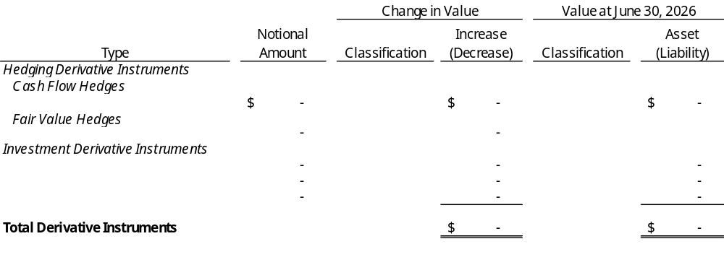
At June 30, 2026, the University determined that the [type of derivative (i.e. pay-fixed interest rate swap for the 20X8 bonds)] no longer met the criteria for effectiveness; therefore, it is reported as an investment derivative instrument. Accordingly, the accumulated changes in the value of the [type of derivative (i.e. swap)] of $___ as of June 30, 2026 and the change in value of the [type of derivative (i.e. swap)] of $____ during fiscal year 2025 are netted. The net amount of $____ is included in investment income for the year ended June 30, 2026.
Hedging derivative instruments held at June 30, 2026 are as follows:
[Note to Preparer: The Terms column below should include all disclosures required by GASB 53, paragraph 72(b), (c), and (e) (if applicable). Please see GASB 53 to ensure all relevant disclosures are included.]

Hedging Derivative Risks
Credit Risk: At June 30, 2026, hedging derivatives reported as assets expose the University to credit risk as follows:
[Note to Preparer: Only derivatives with a positive value (asset) should be included in the following table. If the University has a derivative with a negative value (liability) with the same counterparty, include these as a Netting Arrangement Liability (i.e. a Netting Arrangement Liability should only be included for a counterparty with a derivative asset to offset). The Netting Arrangement Liability should be listed once per counterparty.]
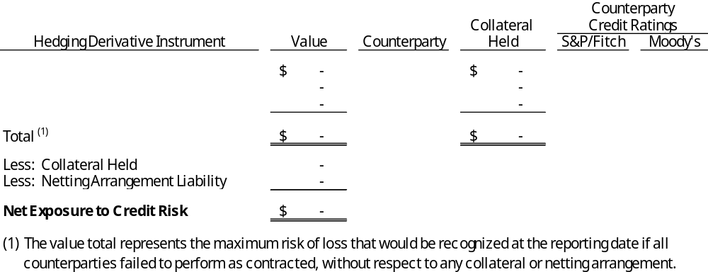
The University does not have a formal policy regarding requiring collateral or other security to support hedging derivative instruments subject to credit risk. [If formal policy exists, replace the previous sentence with a summary description and the aggregate amount of the collateral or other security that reduced credit risk exposure, and information about the University’s access to that collateral or other security.] The University does not have a formal policy regarding entering into master netting arrangements. [Previous sentence assumes the University has entered into more than one derivative instrument transaction with a counterparty and has no formal policy. If the University has not entered into more than one derivative instrument transaction with a counterparty, omit the previous sentence. If the University has and a formal policy exists, replace the previous sentence with a summary description and provide the aggregate amount of liabilities included in those arrangements in the previous table.]
Interest Rate Risk: The University is exposed to interest rate risk on its [type of hedging derivative (i.e. interest rate swaps)]. The values of these instruments are highly sensitive to interest rate changes. [Describe how the hedging derivative investment is exposed by either stating when it matures (i.e., less than a year, 1-5, 6-10, or more than 10) or how it is affected by interest rates. See GASB 53 for disclosure requirements (paragraph 76) and illustrative disclosures.]
Basis Risk: The University is exposed to basis risk because [name of hedging derivative] is [describe how the instrument exposes the University to basis risk. Be sure to include the hedging derivative instrument’s terms and payment terms of the hedged item that creates the basis risk]. [Omit if not applicable.]
Termination Risk: The University is exposed to termination risk because [name of hedging derivative] is [describe how the instrument exposes the University to termination risk. Be sure to include 1) Any termination events that have occurred, 2) Dates that the hedging derivative instrument may be terminated, and 3) Out-of-the-ordinary termination events contained in contractual documents]. [Omit if not applicable.]
Rollover Risk: The University is exposed to rollover risk because [name of hedging derivative] is [describe how the instrument exposes the University to rollover risk. Be sure to include the maturity of the hedging derivative instrument and the maturity of the hedged item]. [Omit if not applicable.]
Market-Access Risk: The University is exposed to market-access risk because [name of hedging derivative] is [describe how the instrument exposes the University to market-access risk]. [Omit if not applicable.]
Foreign Currency Risk: [See GASB 53 paragraph 73 (g).] The University is exposed to foreign currency risk as [name of hedging derivative] is denominated in [type of currency]. [Omit if not applicable.]
[Note to Preparer: If the University used a method to evaluate the effectiveness of the hedging derivative other than a method specified in GASB 53, additional disclosures are required. See GASB 53 paragraph 75 for disclosure requirements.]
Investment Derivative Risks
Credit Risk: At June 30, 2026, investment derivatives reported as assets expose the University to credit risk as follows:
[Note to Preparer: Only derivatives with a positive value (asset) should be included in the following table. If the University has a derivative with a negative value (liability) with the same counterparty, include these as a Netting Arrangement Liability (i.e. a Netting Arrangement Liability should only be included for a counterparty with a derivative asset to offset). The Netting Arrangement Liability should be listed once per counterparty.]
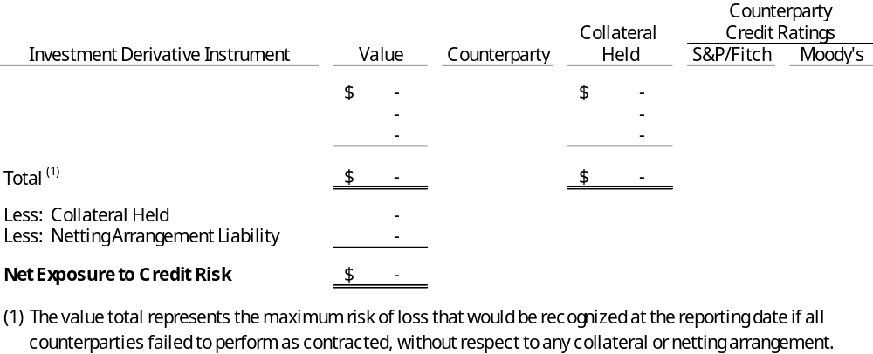
The University does not have a formal policy regarding requiring collateral or other security to support investment derivative instruments subject to credit risk. [If formal policy exists, replace the previous sentence with a summary description and the aggregate amount of the collateral or other security that reduced credit risk exposure, and information about the University’s access to that collateral or other security.] The University does not have a formal policy regarding entering into master netting arrangements. [Previous sentence assumes the University has entered into more than one derivative instrument transaction with a counterparty and has no formal policy. If the University has not entered into more than one derivative instrument transaction with a counterparty, omit the previous sentence. If the University has and a formal policy exists, replace the previous sentence with a summary description and provide the aggregate amount of liabilities included in those arrangements in the previous table.]
Interest Rate Risk: The University is exposed to interest rate risk on its [type of investment derivative]. The values of these instruments are highly sensitive to interest rate changes. [Describe how the investment derivative investment is exposed by either stating when it matures (i.e., less than a year, 1-5, 6-10, or more than 10) or how it is affected by interest rates. See GASB 53 for disclosure requirements (paragraph 76) and illustrative disclosures.]
Foreign Currency Risk: [See GASB 53 paragraph 73 (g).] The University is exposed to foreign currency risk as [name of investment derivative] is denominated in [type of currency]. [Omit if not applicable.]

Note 13 - Leases and Subscription-Based Information Technology Arrangements
- Lessor Arrangements - The University leases [office space and equipment to both external and related parties]. The leases expire at various dates, and some have renewal options. Lease receivables and related deferred inflows of resources are recorded based on the present value of expected receipts over the term of the respective leases. The expected receipts are discounted using the interest rate stated per the lease contract, or the University’s estimated incremental borrowing rate if there is no stated contractual interest rate.
[Note to preparer: See GASB Statement No. 87, paragraph 37 and 57 for disclosure requirements. An example is provided as follows:] Measurement of the lease receivable excluded the following variable payment amounts: the increase or decrease in payments after the initial measurement of the lease receivable that depend on changes in an index or rate (such as the Consumer Price Index). [The University recognized revenues of $_____ during the fiscal year for these changes in variable payments not previously included in the measurement of the lease receivable. The University also recognized revenues of $_____ for residual value guarantees and $_____ for termination payments not previously included in the measurement of the lease receivable.] or [During the year the University did not recognize any variable payment amounts.]
[Note to preparer: Additional disclosures are required if the University, as lessor, has issued debt for which the principal and interest payments are secured by the lease payments and the lessee has options to terminate the lease or abate payments. See GASB 87 paragraph 57d.]
[Note to preparer: Additional disclosures may be required for lease of investment assets, certain regulated leases, sublease transaction, sale-lease back transactions, and lease-leaseback transactions. See GASB 87 paragraphs 58-60.]
During the year ended June 30, 2026, the University recognized operating revenues related to lessor arrangements totaling $XX,XXX, and nonoperating lease interest income totaling $XX,XXX.
The University’s lessor arrangements at June 30, 2026, are summarized below (excluding short-term leases):
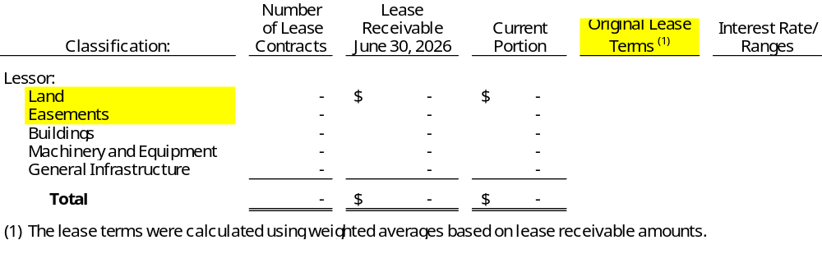
- Lessee Arrangements - The University has lease agreements [for the right to use office space and equipment from both external and related parties]. The leases expire at various dates, and some have renewal options. Lease liabilities and right-to-use leased assets are recorded at the present value of payments expected to be made during the lease term, plus any upfront payments and ancillary charges paid to place the underlying right-to-use asset into service. The expected payments are discounted using the interest rate stated per the lease contract, or the University’s estimated incremental borrowing rate if there is no stated contractual interest rate.
[Note to preparer: See GASB Statement No. 87, paragraph 37 and 57 for disclosure requirements. An example is provided as follows:] Measurement of the lease liability excluded the following variable payment amounts: 1) the increase or decrease in payments after the initial measurement of the lease liability that depend on changes in an index or rate (such as the Consumer Price Index) and 2) payments based on future performance or usage of the underlying assets. [During the fiscal year, the University recognized expenses of $______ for these changes in variable payments not previously included in the measurement of the lease liability. The University also recognized expenses of $_____ for residual value guarantees and $_____ for termination payments not previously included in the measurement of the lease liability.] or [During the year the University did not recognize any variable payment amounts.]
The University had commitments under leases before the lease term as follows: a xxxx-year lease agreement for the right-to-use _____ (describe leased asset) beginning ____ (insert commencement date) with total payments over the period of $_____. [remove if none]
[Note to preparer: If a leased asset is impaired (described in paragraph 9 of Statement 42) additional disclosures are required. See GASB 87 paragraph 34 and 37h for additional information.]
[Note to preparer: The amount of collateral pledged as a security for a lease should be disclosed unless that collateral is solely the asset underlying the lease. See GASB 87 paragraph 39.]
[Note to preparer: GASB 87 requires additional disclosures for sublease transactions, sale-leaseback transactions, and lease-leaseback transactions. See GASB 87 paragraph 38 for further information.]
The University’s lessee arrangements at June 30, 2026, are summarized below (excluding short-term leases):
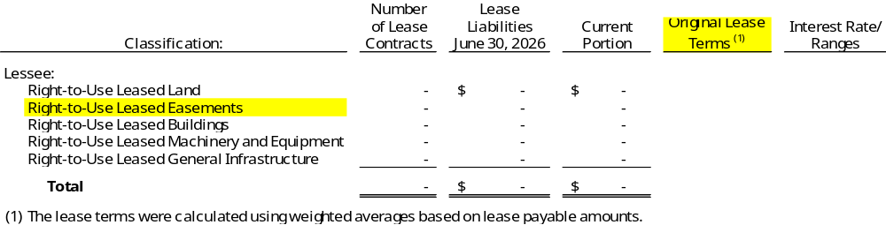
- Subscription-Based Information Technology Arrangements (SBITAs) - The University enters SBITAs for [the right to use information technology software and cloud computing arrangement (network) assets from both external and related parties]. The SBITAs expire at various dates, and some have renewal options. Subscription liabilities and the related right-to-use subscription assets are recorded based on the present value of expected payments over the term of the respective SBITA. The expected payments are discounted using the interest rate stated per the SBITA contract, or the University’s estimated incremental borrowing rate if there is no stated contractual interest rate.
[Note to preparer: See GASB Statement No. 96, paragraph 17 and 60 for disclosure requirements. An example is provided as follows:] Measurement of the subscription liability excluded the following variable payment amounts: 1) the increase or decrease in payments after the initial measurement of the subscription liability that depend on changes in an index or rate (such as the Consumer Price Index) and 2) payments based on future performance or usage of the underlying assets. [During the fiscal year, the University recognized expenses of $______ for these changes in variable payments not previously included in the measurement of the subscription liability. The University also recognized expenses of $_____ for termination payments not previously included in the measurement of the subscription liability.] or [During the year the University did not recognize any variable payment amounts.]
The University had commitments under SBITAs before the SBITA term as follows: a xxxx-year SBITA for the right-to-use _____ (describe subscription asset) beginning ____ (insert commencement date) with total payments over the period of $_____. [remove if none, see GASB 96 paragraph 26, 35 and 60]
[Note to preparer: If a SBITA asset is impaired (described in paragraph 9 of Statement 42) additional disclosures are required. See GASB 96 paragraphs 41 and 60]
The University’s SBITAs at June 30, 2026, are summarized below (excluding short-term SBITAs):
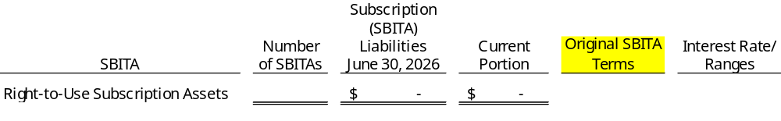
- Annual Requirements - The annual requirements to pay principal and interest on leases and SBITAs at June 30, 2026, are as follows:
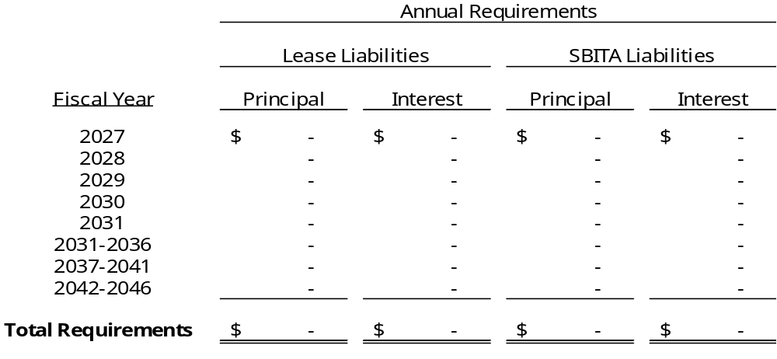

Note 14 - Net Position
[Per GASB 63 paragraph 14, describe any transactions that resulted in the recognition of a deferred outflow of resources or deferred inflow of resources in which a component of net position has been significantly affected. Common examples from the recognition of net pension liability and net OPEB liability have been provided below. Other possible items include Service Concession Arrangements and Asset Retirement Obligations.]
Unrestricted net position has been significantly affected by transactions resulting from the recognition of deferred outflows of resources, deferred inflows of resources, and related
long-term liabilities, as shown in the following table:
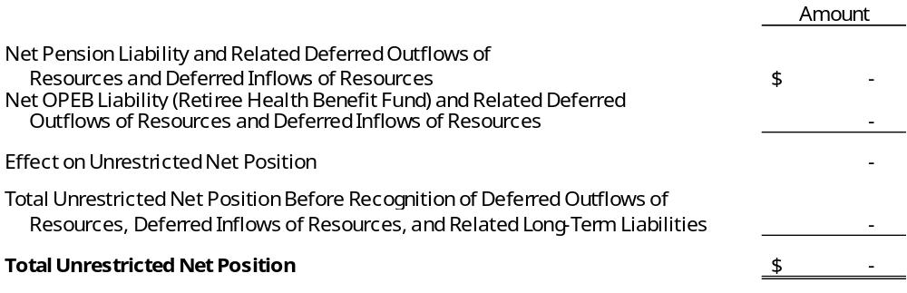
See Notes XX and XX for detailed information regarding the amortization of the deferred outflows of resources and deferred inflows of resources relating to pensions and OPEB, respectively [modify to reference pension and OPEB disclosures].

Note 15 - Revenues
A summary of discounts and allowances by revenue classification is presented as follows:
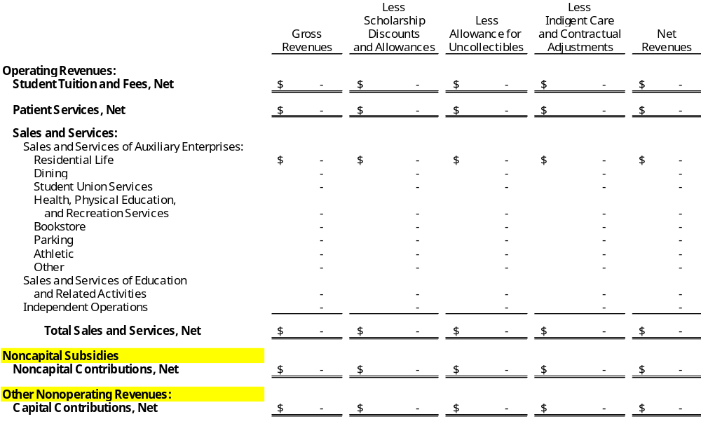
[Note to Preparer: GASB Codification Section 2200.191 requires revenues to be reported by major source. The level of disaggregation of sales and services is up to the discretion of the University based on the activity of each source of revenue. If the University does not have items (i.e. noncapital contributions, capital contributions, etc.) that are net of eliminations, discounts, uncollectibles, or other adjustments, they can be removed from the table above]

Note 16 - Operating Expenses by Function
The University’s operating expenses by functional classification are presented as follows: [If capital asset impairment reported on face of statements, add column here and reflect in appropriate function.]
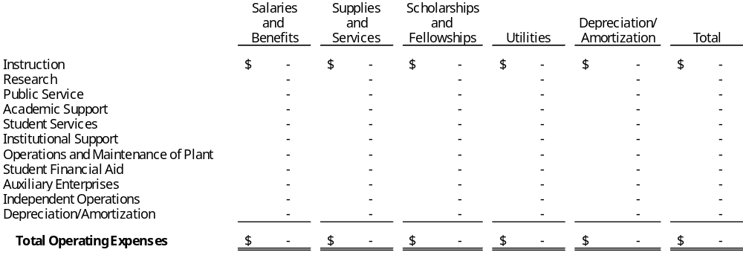

Note 17 - Retirement Plans
- Defined Benefit Plan
Plan Administration: The State of North Carolina administers the Teachers’ and State Employees’ Retirement System (TSERS) plan. This plan is a cost-sharing, multiple-employer, defined benefit pension plan established by the State to provide pension benefits for general employees and law enforcement officers (LEOs) of the State, general employees and LEOs of its component units, and employees of Local Education Agencies (LEAs) and charter schools not in the reporting entity. Membership is comprised of employees of the State (State agencies and institutions), universities, community colleges, LEAs, and certain proprietary component units along with charter schools that elect to join the Retirement System. Effective January 1, 2024, new employees hired by UNC Health Care or by certain components of East Carolina University, who are not law enforcement officers and were not actively contributing to TSERS immediately before they were hired by those entities, are not eligible to join TSERS. Benefit provisions are established by N.C.G.S. §135-5 and may be amended only by the North Carolina General Assembly.
Benefits Provided: TSERS provides retirement and survivor benefits. Unreduced retirement benefits are determined as 1.82% of the member’s average final compensation times the member’s years of creditable service. A member’s average final compensation is calculated as the average of a member’s four highest consecutive years of compensation. General employee plan members are eligible to retire with unreduced retirement benefits at age 65 with five years of membership service, at age 60 with 25 years of creditable service, or at any age with 30 years of creditable service. General employee plan members are eligible to retire with reduced retirement benefits at age 50 with 20 years of creditable service or at age 60 with five years of membership service. Survivor benefits are available to eligible beneficiaries of general members who die while in active service or within 180 days of their last day of service and who also have either completed 20 years of creditable service regardless of age or have completed five years of service and have reached age 60. Eligible beneficiaries may elect to receive a monthly Survivor’s Alternate Benefit for life in lieu of the return of the member’s contributions that is generally available to beneficiaries of deceased members. The plan does not provide for automatic post-retirement benefit increases.
Contributions: Contribution provisions are established by N.C.G.S. §135-8 and may be amended only by the North Carolina General Assembly. Plan members are required to contribute 6% of their annual pay. The contribution rate for employers is set each year by the North Carolina General Assembly in the Appropriations Act and may not be less than the contribution rate required of plan members. The TSERS Board of Trustees establishes a funding policy from which an accrued liability rate and a normal contribution rate are developed by the consulting actuary. The sum of those two rates developed under the funding policy is the actuarially determined contribution rate (ADC). The TSERS Board of Trustees may further adopt a contribution rate policy that is higher than the ADC known as the required employer contribution to be recommended to the North Carolina General Assembly. The University’s contractually-required contribution rate for the year ended June 30, 2026 was 17.14% of covered payroll. Plan members’ contributions to the pension plan were $_____, and the University’s contributions were $_____ for the year ended June 30, 2026.
The TSERS plan’s financial information, including all information about the plan’s assets, deferred outflows of resources, liabilities, deferred inflows of resources, and fiduciary net position, is included in the State of North Carolina’s fiscal year 2025 Annual Comprehensive Financial Report. An electronic version of this report is available on the North Carolina Office of the State Controller’s website at https://www.ncosc.gov/ or by calling the State Controller’s Financial Reporting Section at 919-707-0500.
TSERS Basis of Accounting: The financial statements of the TSERS plan are prepared using the accrual basis of accounting. Plan member contributions are recognized in the period in which the contributions are due. Employer contributions are recognized when due and the employer has a legal requirement to provide the contributions. Benefits and refunds are recognized when due and payable in accordance with the terms of each plan. For purposes of measuring the net pension liability, deferred outflows of resources and deferred inflows of resources related to pensions, and pension expense, information about the fiduciary net position of the TSERS plan, and additions to/deductions from the TSERS plan’s fiduciary net position have been determined on the same basis as they are reported by TSERS.
Methods Used to Value TSERS Investment: Pursuant to North Carolina General Statutes, the State Treasurer is the custodian and administrator of the retirement systems. The State Treasurer maintains various investment portfolios in its External Investment Pool. TSERS and other pension plans of the State of North Carolina participate in the Long-Term Investment, Fixed Income Investment, Equity Investment, Real Estate Investment, Alternative Investment, Opportunistic Fixed Income Investment, and Inflation Sensitive Investment portfolios. The Fixed Income Asset Class includes the Long-Term Investment and Fixed Income Investment portfolios. The Global Equity Asset Class includes the Equity Investment portfolio. The investment balance of each pension trust fund represents its share of the fair value of the net position of the various portfolios within the External Investment Pool. Detailed descriptions of the methods and significant assumptions regarding investments of the State Treasurer are provided in the 2025 Annual Comprehensive Financial Report.
Net Pension Liability: At June 30, 2026, the University reported a liability of $_____ for its proportionate share of the collective net pension liability. The net pension liability was measured as of June 30, 2025. The total pension liability used to calculate the net pension liability was determined by an actuarial valuation as of December 31, 2024, and update procedures were used to roll forward the total pension liability to June 30, 2025. The University’s proportion of the net pension liability was based on a projection of the present value of future salaries for the University relative to the projected present value of future salaries for all participating employers, actuarially-determined. As of June 30, 2025, the University’s proportion was ___%, which was an/a [increase/decrease] of ___ from its proportion measured as of June 30, 2024, which was ___%.
Actuarial Assumptions: The following table presents the actuarial assumptions used to determine the total pension liability for the TSERS plan at the actuarial valuation date:
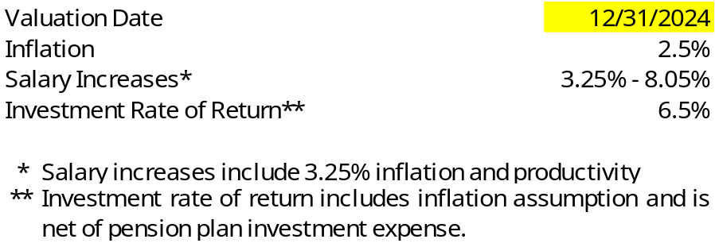
TSERS currently uses mortality tables that vary by age, gender, employee group (i.e., teacher, general, law enforcement officer) and health status (i.e., disabled and healthy). The current mortality rates are based on published tables and based on studies that cover significant portions of the U.S. public plan population. The mortality rates also contain a provision to reflect future mortality improvements.
The actuarial assumptions used in the December 31, 2024 valuation were based on
the results of an actuarial experience review for the period January 1, 2015 through
December 31, 2019.
Future ad hoc cost-of-living adjustment amounts are not considered to be substantively automatic and are therefore not included in the measurement. The projected long-term investment returns and inflation assumptions are developed through review of current and historical capital markets data, sell-side investment research, consultant whitepapers, and historical performance of investment strategies. Fixed income return projections reflect current yields across the U.S. Treasury yield curve and market expectations of forward yields projected and interpolated for multiple tenors and over multiple year horizons. Global public equity return projections are established through analysis of the equity risk premium and the fixed income return projections. Other asset categories and strategies’ return projections reflect the foregoing and historical data analysis. These projections are combined to produce the long-term expected rate of return by weighting the expected future real rates of return by the target asset allocation percentage and by adding expected inflation. Best estimates of arithmetic real rates of return for each major asset class included in the pension plan’s target asset allocation as of June 30, 2025 (the measurement date) are summarized in the following table:
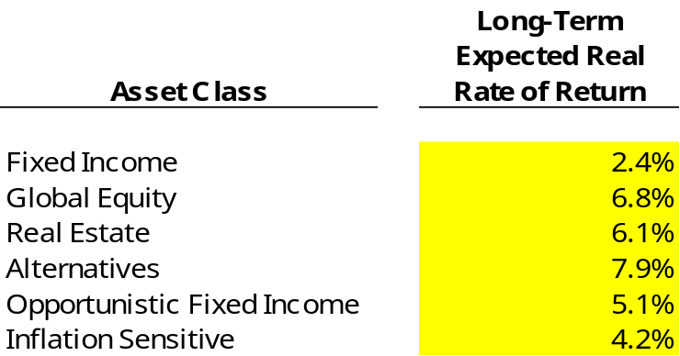
The information in the preceding table is based on 30-year expectations developed with an investment consulting firm. The long-term nominal rates of return underlying the real rates of return are arithmetic annual figures. The real rates of return are calculated from nominal rates by multiplicatively subtracting a long-term inflation assumption of 2.38%. Return projections do not include any excess return expectations over benchmark averages for public markets. All rates of return and inflation are annual amounts. The long-term expected real rate of return for the Bond Index Investment Pool as of June 30, 2025 is 2.53%.
Discount Rate: The discount rate used to measure the total pension liability was 6.5% for the December 31, 2024 valuation. The discount rate is in line with the long-term nominal expected return on pension plan investments. The calculation of the net pension liability is a present value calculation of the future net pension payments. These net pension payments assume that contributions from plan members will be made at the current statutory contribution rate and that contributions from employers will be made at the contractually required rates, actuarially determined. Based on those assumptions, the pension plan’s fiduciary net position was projected to be available to make all projected future benefit payments of the current plan members. Therefore, the long-term expected rate of return on pension plan investments was applied to all periods of projected benefit payments to determine the total pension liability.
Sensitivity of the Net Pension Liability to Changes in the Discount Rate: The following presents the net pension liability of the plan at June 30, 2025 calculated using the discount rate of 6.5%, as well as what the net pension liability would be if it were calculated using a discount rate that is 1-percentage-point lower (5.5%) or 1-percentage-point higher (7.5%) than the current rate:
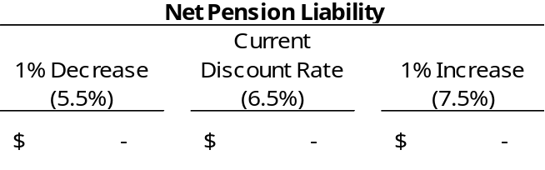
Deferred Outflows of Resources and Deferred Inflows of Resources Related to Pensions: For the year ended June 30, 2026, the University recognized pension expense of $_____.
At June 30, 2026, the University reported deferred outflows of resources and deferred inflows of resources related to TSERS from the following sources:
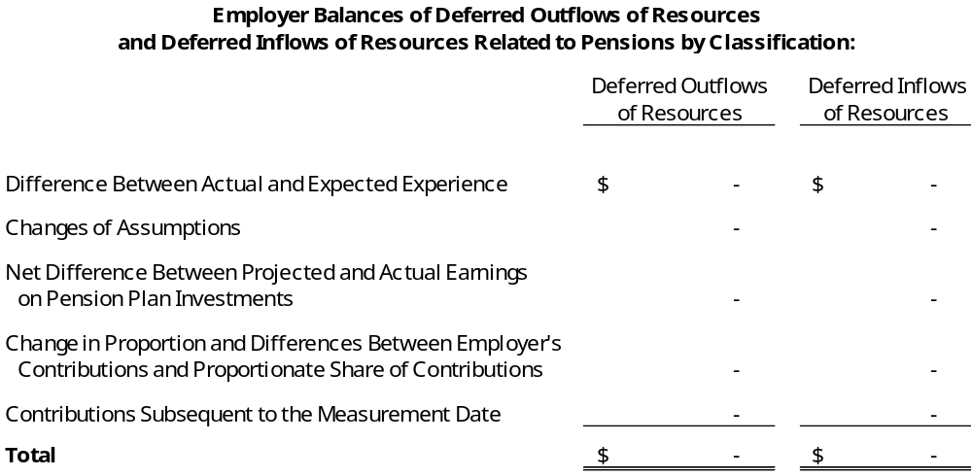
The amount reported as deferred outflows of resources related to contributions subsequent to the measurement date will be recognized as a reduction of the net pension liability in the fiscal year ending June 30, 2027. Other amounts reported as deferred outflows of resources and deferred inflows of resources related to TSERS will be recognized as pension expense as follows:
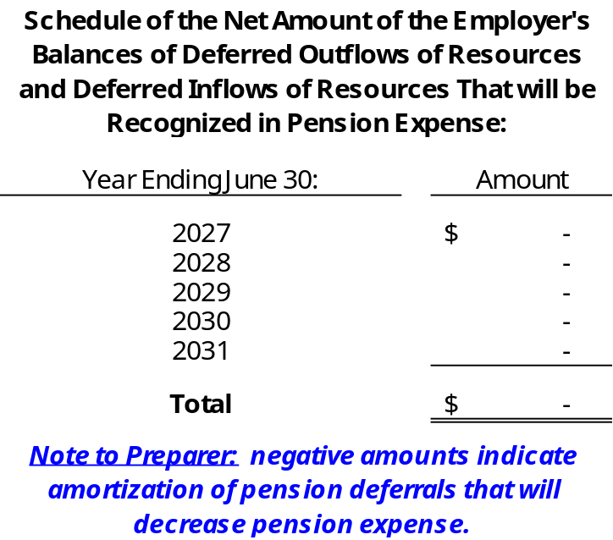
- Defined Contribution Plan - The Optional Retirement Program (ORP) is a defined contribution pension plan that provides retirement benefits with options for payments to beneficiaries in the event of the participant’s death. Faculty and staff of the University may join the ORP instead of TSERS. The ORP is administered by the UNC System.
Benefits are provided by means of contracts issued and administered by the
privately-operated Teachers’ Insurance and Annuity Association. Participants’ eligibility and contributory requirements are established in N.C.G.S. §135-5.1 and may be amended only by the North Carolina General Assembly. Participants are always fully vested in their own contributions to the plan and their investment earnings. Participants are fully vested in the University’s contributions and earnings after five years of participating in the ORP.
Participants contribute 6% of compensation and the University contributes 6.84%. For the year ended June 30, 2026, the University had a total payroll of $____, of which $____ was covered under ORP. Total employee and employer contributions for pension benefits for the year were $____ and $_____, respectively. The amount of pension expense recognized in the current year related to ORP is equal to the employer contributions. [Note to preparer: If your entity reported a liability for ORP, such as a current payable for contributions made, you should disclose this information here. Additionally, if your entity had forfeitures reflected in salaries and benefits expense, the amount must also be disclosed.]

Note 18 - Other Postemployment Benefits
The University participates in two postemployment benefit plans, the Retiree Health Benefit Fund and the Disability Income Plan of North Carolina, that are administered by the State of North Carolina as pension and other employee benefit trust funds. Each plan’s financial information, including all information about the plans’ assets, deferred outflows of resources, liabilities, deferred inflows of resources, and fiduciary net position, is included in the State of North Carolina’s fiscal year 2025 Annual Comprehensive Financial Report. An electronic version of this report is available on the North Carolina Office of the State Controller’s website at https://www.ncosc.gov/ or by calling the State Controller’s Financial Reporting Section at
919-707-0500.
- Summary of Significant Accounting Policies and Plan Asset Matters
Basis of Accounting: The financial statements of these plans were prepared using the accrual basis of accounting. Employer contributions are recognized when due and the employer has made a formal commitment to provide the contributions. Benefits are recognized when due and payable in accordance with the terms of each plan. For purposes of measuring the net other postemployment benefits (OPEB) liability, deferred outflows of resources and deferred inflows of resources related to OPEB, and OPEB expense, information about the fiduciary net position of each plan, and additions to/deductions from each plans’ fiduciary net position have been determined on the same basis as they are reported by the plans.
Methods Used to Value Plan Investments: Pursuant to North Carolina General Statutes, the State Treasurer is the custodian and administrator of the other postemployment benefit funds. The State Treasurer maintains various investment portfolios in its External Investment Pool. The Retiree Health Benefit Fund participates in the External Investment Pool. The Disability Income Plan is invested in the Short-Term Investment Portfolio of the External Investment Pool and the Bond Index External Investment Pool. Detailed descriptions of the methods and significant assumptions regarding investments of the State Treasurer are provided in the 2025 Annual Comprehensive Financial Report.
- Plan Descriptions
- Health Benefits
Plan Administration: The State of North Carolina administers the North Carolina State Health Plan for Teachers and State Employees, referred to as the State Health Plan (the Plan), a healthcare plan exclusively for the benefit of employees of the State, the University of North Carolina System, community colleges, and certain other component units. In addition, Local Education Agencies (LEAs), charter schools, and some select local governments that are not part of the State’s financial reporting entity also participate. Health benefit programs and premium rates are determined by the State Treasurer upon approval of the Plan Board of Trustees.
The Retiree Health Benefit Fund (RHBF) has been established by N.C.G.S. §135-7(f)
as a fund to provide health benefits to retired and disabled employees and their applicable beneficiaries. RHBF is a cost-sharing, multiple-employer, defined benefit healthcare plan, exclusively for the benefit of former employees of the State, the University of North Carolina System, and community colleges. In addition, LEAs, charter schools, and some select local governments that are not part of the State’s financial reporting entity also participate.
By statute, RHBF is administered by the Board of Trustees of the Teachers’ and State Employees’ Retirement System (TSERS). RHBF is supported by a percent of payroll contribution from participating employing units. Each year the percentage is set in legislation. The State Treasurer, with the approval of the Plan Board of Trustees, then sets the employer contributions (subject to the legislative cap) and the premiums to be paid by retirees, as well as the health benefits to be provided through the Plan.
Benefits Provided: Plan benefits received by retired employees and disabled employees from RHBF are OPEB. The healthcare benefits for retired and disabled employees who are not eligible for Medicare are the same as for active employees
as described in Note XX. The plan options change when the former employees
become eligible for Medicare. The benefits provided include medical and pharmacy coverage for employees and their dependents. Non-Medicare eligible members have two self-funded options administered by the Plan while Medicare members have three options, including one self-funded option and two fully-insured Medicare Advantage/Prescription Drug Plan options. Self-funded medical and pharmacy claims costs are shared between the covered member and the Plan. If the self-funded plan is elected by a Medicare eligible member, the coverage is secondary to Medicare. Fully-insured claims include cost sharing from covered members with the remaining balance paid by the fully-insured carrier.
Those former employees who are eligible to receive medical benefits from RHBF are long-term disability beneficiaries of the Disability Income Plan of North Carolina and retirees of TSERS, the Consolidated Judicial Retirement System (CJRS), the Legislative Retirement System (LRS), the University Employees’ Optional Retirement Program (ORP), and a small number of local governments, with five or more years of contributory membership service in their retirement system prior to disability or retirement, with the following exceptions: for employees first hired on or after October 1, 2006, and members of the North Carolina General Assembly first taking office on or after February 1, 2007, future coverage as retired employees and retired members of the North Carolina General Assembly is subject to the requirement that the future retiree have 20 or more years of retirement service credit in order to receive coverage on a noncontributory basis. Employees first hired on or after October 1, 2006 and members of the North Carolina General Assembly first taking office on or after February 1, 2007 with 10 but less than 20 years of retirement service credit are eligible for coverage on a partially contributory basis. For such future retirees, the State will pay 50% of the Plan’s total noncontributory premium. Employees first hired on or after October 1, 2006 and members of the North Carolina General Assembly first taking office on or after February 1, 2007 with five but less than 10 years of retirement service credit are eligible for coverage on a fully contributory basis.
Sections 35.21.(c) and (d) of Session Law 2017-57 repealed retiree medical benefits for employees first hired on or after January 1, 2021. The legislation amended Chapter 135, Article 3B of the North Carolina General Statutes to require that retirees must earn contributory retirement service in the TSERS (or in an allowed local system unit), CJRS, or LRS prior to January 1, 2021, and not withdraw that service, in order to be eligible for retiree medical benefits under the amended law. Consequently, members first hired on and after January 1, 2021 will not be eligible to receive retiree medical benefits.
RHBF’s benefit and contribution provisions are established by Chapter 135, Articles 1 and 3B of the North Carolina General Statutes and may be amended only by the North Carolina General Assembly. RHBF does not provide for automatic post-retirement benefit increases.
Contributions: Contribution rates to RHBF, which are intended to finance benefits
and administrative expenses on a pay-as-you-go basis, are determined by the
North Carolina General Assembly in the Appropriations Act. The University’s contractually-required contribution rate for the year ended June 30, 2026 was 7.33% of covered payroll. The University’s contributions to the RHBF were $______ for the year ended June 30, 2026.
In fiscal year 2024, the Plan transferred $10.3 million to RHBF as a result of cost savings to the Plan over a span of six years. For financial reporting purposes, the transfer was recognized as a nonemployer contributing entity contribution. The contribution was allocated among the RHBF employers and recorded as noncapital contributions. For the fiscal year ended June 30, 2026, the University recognized noncapital contributions for RHBF of $________.
- Disability Income
Plan Administration: As discussed in Note XX, short-term and long-term disability benefits are provided through the Disability Income Plan of North Carolina (DIPNC), a cost-sharing, multiple-employer defined benefit plan, to the eligible members of TSERS which includes employees of the State, the University of North Carolina System, community colleges, certain participating component units and LEAs which are not part of the State’s reporting entity, and the University Employees’ ORP. By statute, DIPNC is administered by the Department of State Treasurer and the Board of Trustees of TSERS.
Benefits Provided: Long-term disability benefits are payable as an OPEB from DIPNC after the conclusion of the short-term disability period or after salary continuation payments cease, whichever is later, while the employee is disabled and does not meet the TSERS conditions for unreduced service retirement. Per N.C.G.S. § 135-106 an employee is eligible to receive long-term disability benefits provided the following requirements are met: (1) the employee has five or more years of contributing membership service in TSERS or the University Employees’ ORP, earned within 96 months prior to becoming disabled or cessation of salary continuation payments, whichever is later; (2) the employee must make application to receive long-term benefits within 180 days after the conclusion of the short-term disability period or after salary continuation payments cease or after monthly payments for Workers’ Compensation cease (excluding monthly payments for permanent partial benefits), whichever is later; (3) the employee must be certified by the Medical Board to be mentally or physically disabled for the further performance of his/her usual occupation; (4) the disability must have been continuous, likely to be permanent, and incurred at the time of active employment; (5) the employee must not be eligible to receive an unreduced retirement benefit from TSERS; and (6) the employee must terminate employment as a permanent, full-time employee. A general employee is eligible to receive an unreduced retirement benefit from TSERS after: (1) reaching the age of 65 and completing five years of membership service; (2) reaching the age of 60 and completing 25 years of creditable service; or (3) completing 30 years of creditable service, at any age.
For employees who had five or more years of membership service as of July 31, 2007, during the first 36 months of the long-term disability period, the monthly long-term disability benefit is equal to 65% of one-twelfth of an employee’s annual base rate of compensation last payable to the participant or beneficiary prior to the beginning of the short-term disability period, plus the like percentage of one-twelfth of the annual longevity payment and local supplements to which the participant or beneficiary would be eligible. The monthly benefits are subject to a maximum of $3,900 per month reduced by any primary Social Security disability benefits, by an amount equal to the monthly primary Social Security retirement benefit to which the employee might be entitled should the employee be at least age 62, and by monthly payments for Workers’ Compensation to which the participant or beneficiary may be entitled, but the benefits payable shall be no less than $10 a month. After the first 36 months of the long-term disability, the long-term benefit is calculated in the same manner as described above except the monthly benefit is reduced by an amount equal to a monthly primary Social Security disability benefit to which the participant or beneficiary might be entitled had Social Security disability benefits been awarded. When an employee qualifies for an unreduced service retirement allowance from TSERS, the benefits payable from DIPNC will cease, and the employee will commence retirement under TSERS or the University Employees’ ORP.
For employees who had less than five years of membership service as of
July 31, 2007, and meet the requirements for long-term disability on or after
August 1, 2007, benefits are calculated in the same manner as described above except that after the first 36 months of the long-term disability, no further long-term disability benefits are payable unless the employee has been approved and is in receipt of primary Social Security disability benefits.
Benefit and contribution provisions are established by Chapter 135, Article 6, of the North Carolina General Statutes and may be amended only by the North Carolina General Assembly. The plan does not provide for automatic post-retirement benefit increases.
Contributions: Disability income benefits are funded by actuarially determined employer contributions that are established in the Appropriations Act by the North Carolina General Assembly and coincide with the State’s fiscal year. The University’s contractually-required contribution rate for the year ended June 30, 2026 was 0.07% of covered payroll. The University’s contributions to DIPNC were $______ for the year ended June 30, 2026.
- Net OPEB Liability (Asset)
Retiree Health Benefit Fund: At June 30, 2026, the University reported a liability of $_____ for its proportionate share of the collective net OPEB liability for RHBF. The net OPEB liability was measured as of June 30, 2025. The total OPEB liability used to calculate the net OPEB liability was determined by an actuarial valuation as of December 31, 2024, and update procedures were used to roll forward the total OPEB liability to June 30, 2025. The University’s proportion of the net OPEB liability was based on a projection of the present value of future salaries for the University relative to the projected present value of future salaries for all participating employers, actuarially-determined. As of June 30, 2025, the University’s proportion was ___%, which was an/a [increase/decrease] of ___ from its proportion measured as of June 30, 2024, which was ____%.
Disability Income Plan of North Carolina: At June 30, 2026, the University reported an asset of $_____ for its proportionate share of the collective net OPEB asset for DIPNC. The net OPEB asset was measured as of June 30, 2025. The total OPEB liability used to calculate the net OPEB asset was determined by an actuarial valuation as of December 31, 2024, and update procedures were used to roll forward the total OPEB liability to June 30, 2025. The University’s proportion of the net OPEB asset was based on a projection of the present value of future salaries for the University relative to the projected present value of future salaries for all participating employers, actuarially-determined. As of June 30, 2025, the University’s proportion was ___%, which was an/a [increase/decrease] of ___ from its proportion measured as of June 30, 2024, which was ____%.
Actuarial Assumptions: The total OPEB liabilities for RHBF and DIPNC were determined by actuarial valuations as of December 31, 2024, using the following actuarial assumptions, applied to all periods included in the measurement, unless otherwise specified. The total OPEB liabilities were then rolled forward to June 30, 2025 utilizing update procedures incorporating the actuarial assumptions.
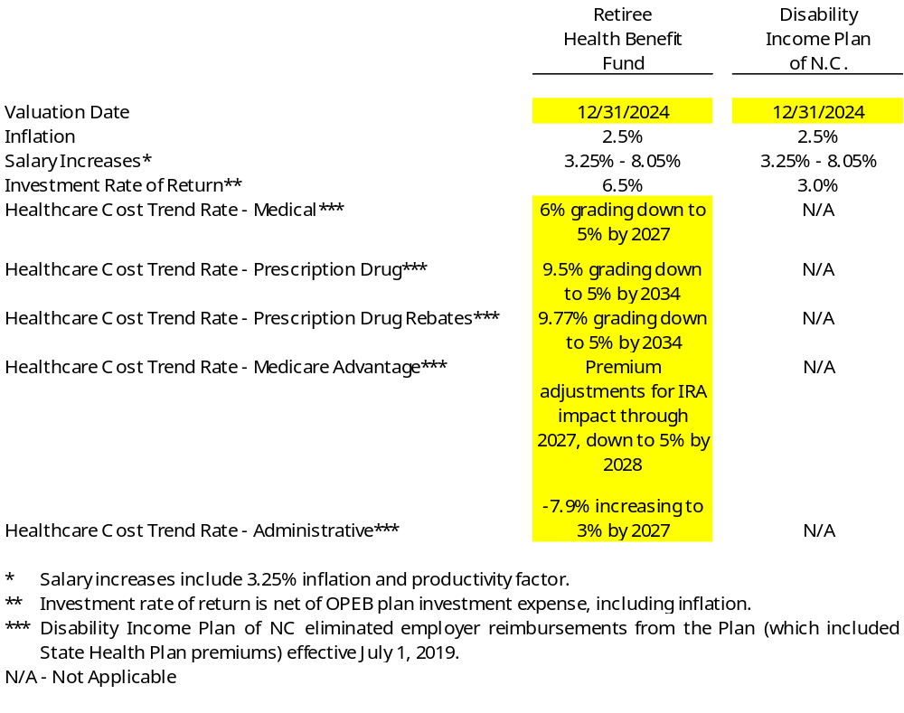
The OPEB plans currently use mortality tables that vary by age, gender, employee group
(i.e., teacher, other educational employee, general employee, or law enforcement officer) and health status (i.e., disabled or not disabled). The current mortality rates are based on published tables and studies that cover significant portions of the U.S. public plan population. The healthy mortality rates also contain a provision to reflect future mortality improvements.
The projected long-term investment returns and inflation assumptions are developed through review of current and historical capital markets data, sell-side investment research, consultant whitepapers, and historical performance of investment strategies. Fixed income return projections reflect current yields across the U.S. Treasury yield curve and market expectations of forward yields projected and interpolated for multiple tenors and over multiple year horizons. Global public equity return projections are established through analysis of the equity risk premium and the fixed income return projections. Other asset categories and strategies’ return projections reflect the foregoing and historical data analysis. These projections are combined to produce the long-term expected rate of return by weighting the expected future real rates of return by the target asset allocation percentage and by adding expected inflation. DIPNC is primarily invested in the Bond Index Investment Pool as of June 30, 2025.
Best estimates of real rates of return for each major asset class included in RHBF’s target asset allocation as of June 30, 2025 (the measurement date) are summarized in the following table:
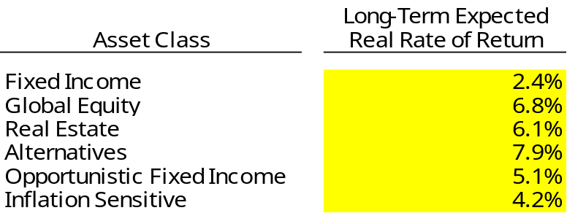
The information in the preceding table is based on 30-year expectations developed with an investment consulting firm. The long-term nominal rates of return underlying the real rates of return are arithmetic annual figures. The real rates of return are calculated from nominal rates by multiplicatively subtracting a long-term inflation assumption of 2.38%. Return projections do not include any excess return expectations over benchmark averages for public markets. All rates of return and inflation are annual amounts. The long-term expected real rate of return for the Bond Index Investment Pool as of June 30, 2025 is 2.53%. The total return for the Bond Index Investment Pool is expected to exceed the assumed investment rate of return of 3% used to measure the total OPEB liability for DIPNC. As such, the investment rate of return of 3% includes a provision for adverse deviation.
Actuarial valuations of the plans involve estimates of the value of reported amounts and assumptions about the probability of occurrence of events far into the future. The results of the valuations fluctuate from year to year as actual experience differs from assumptions. This includes demographic experiences (i.e., mortality and retirement) that differ from expected. This also includes financial experiences (i.e., member medical costs and contributions) that vary from expected trends. Actuarially determined amounts are subject to continual revision as actual results are compared to past expectations and new estimates are made about the future.
The actuarial assumptions used for RHBF are consistent with those used to value
the pension benefits of TSERS where appropriate. These assumptions are based on
the most recent pension valuations available. The discount rate used for RHBF reflects a pay-as-you-go approach.
Projections of benefits for financial reporting purposes of the plans are based on the substantive plan (the plan as understood by the employer and plan members) and include the types of benefits provided at the time of each valuation and the historical pattern of sharing of benefit costs between the employer and plan members to that point. The RHBF is funded solely by employer contributions and benefits are dependent on membership requirements.
The actuarial methods and assumptions used for DIPNC include techniques that are designed to reduce the effects of short-term volatility in actuarial accrued liabilities and the actuarial value of assets, consistent with the long-term perspective of the calculations.
The actuarial assumptions used in the December 31, 2024 valuations were generally based on the results of an actuarial experience study prepared as of December 31, 2019, as amended for updates to certain assumptions (such as medical claims and medical trend rate assumptions) implemented based on annual reviews that have occurred since that experience study.
Discount Rate: The discount rate used to measure the total OPEB liability for RHBF was 5.2% at June 30, 2025 compared to 3.93% at June 30, 2024. The projection of cash flow used to determine the discount rate assumed that contributions from employers would be made at the current statutorily determined contribution rate. Based on the above assumptions, the plan’s fiduciary net position was not projected to be available to make projected future benefit payments to current plan members. As a result, a municipal bond rate of 5.2% was used as the discount rate used to measure the total OPEB liability. The 5.2% rate is based on the Bond Buyer 20-year General Obligation Index as of June 30, 2025.
The discount rate used to measure the total OPEB liability for DIPNC was 3% at
June 30, 2025 and at June 30, 2024. The projection of cash flow used to determine the discount rate assumed that contributions from plan members would be made at the current contribution rate and that contributions from employers would be made at statutorily required rates, actuarially determined. Based on those assumptions, the plan’s fiduciary net position was projected to be available to make all projected future benefit payments to the current plan members.
Sensitivity of the Net OPEB Liability (Asset) to Changes in the Discount Rate: The following presents the University’s proportionate share of the net OPEB liability (asset) of the plans, as well as what each plans’ net OPEB liability (asset) would be if it were calculated using a discount rate that is 1-percentage-point lower or 1-percentage-point higher than the current discount rate:
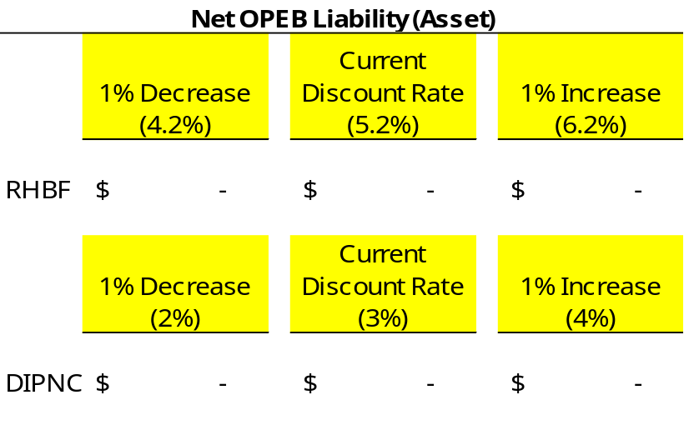
Sensitivity of the Net OPEB Liability to Changes in the Healthcare Cost Trend Rates: The following presents the net OPEB liability of the plans, as well as what the plans’ net OPEB liability would be if it were calculated using healthcare cost trend rates that are
1-percentage-point lower or 1-percentage-point higher than the current healthcare cost trend rates:
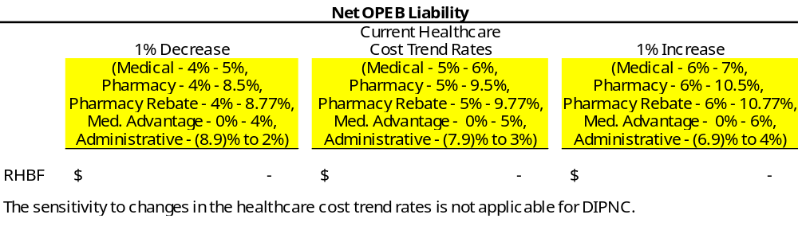
OPEB Expense: For the fiscal year ended June 30, 2026, the University recognized OPEB expense as follows:
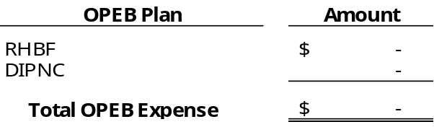
Deferred Outflows of Resources and Deferred Inflows of Resources Related to OPEB: At
June 30, 2026, the University reported deferred outflows of resources and deferred inflows of resources related to OPEB from the following sources:
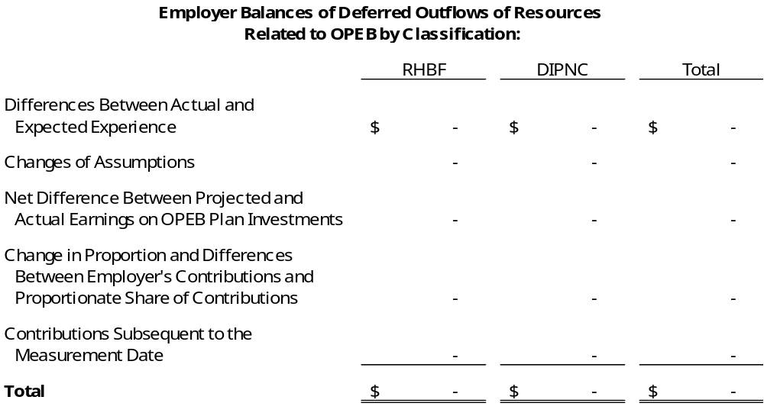
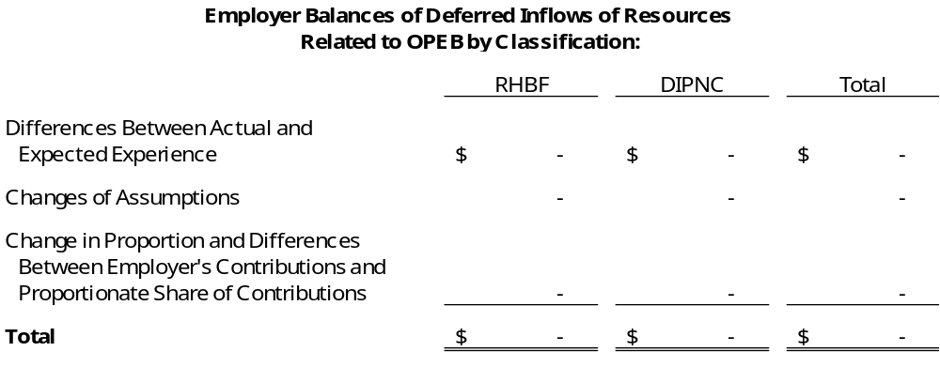
Amounts reported as deferred outflows of resources related to contributions subsequent to the measurement date will be recognized as a reduction of the net OPEB liability (asset) related to RHBF and an increase of the net OPEB asset related to DIPNC in the fiscal year ending June 30, 2027. Other amounts reported as deferred outflows of resources and deferred inflows of resources related to OPEB will be recognized as OPEB expense as follows:
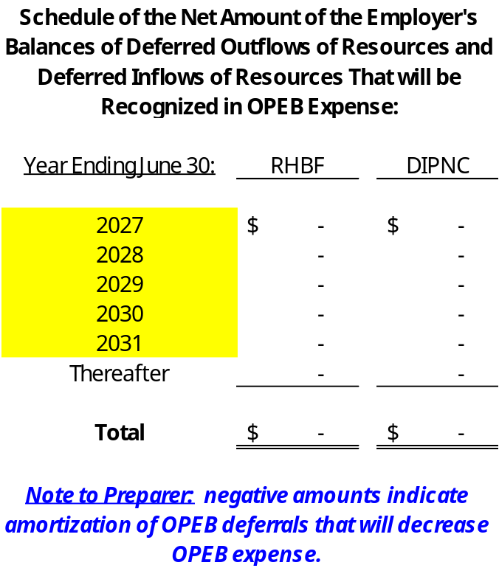

Note 19 - Risk Management
The University is exposed to various risks of loss related to torts; theft of, damage to, and destruction of assets; errors and omissions; injuries to employees; and natural disasters. These exposures to loss are handled via a combination of methods, including participation in state-administered insurance programs, purchase of commercial insurance, and self-retention of certain risks. There have been no significant reductions in insurance coverage from the previous year and settled claims have not exceeded coverage in any of the past three fiscal years. [Revise previous sentence as necessary.]
- Employee Benefit Plans
- State Health Plan
University employees are provided comprehensive major medical care benefits. Coverage is funded by contributions to the State Health Plan (Plan), a discretely presented component unit of the State of North Carolina. The Plan is funded by employer and employee contributions. The Plan has contracted with third parties to process claims. See Note XX, Other Postemployment Benefits, for additional information regarding retiree health benefits.
- Death Benefit Plan of North Carolina
Term life insurance (death benefits) of $25,000 to $50,000 is provided to eligible workers who enroll in the Teachers’ and State Employees’ Retirement System. This Death Benefit Plan is administered by the State Treasurer and funded via employer contributions. The employer contribution rate was 0.13% for the current fiscal year.
- Disability Income Plan
Short-term and long-term disability benefits are provided to University employees through the Disability Income Plan of North Carolina (DIPNC), part of the State’s Pension and Other Employee Benefit Trust Funds. Short-term benefits are paid by the University for up to twelve months. The Board of Trustees of the DIPNC may extend the short-term disability benefits for up to an additional twelve months. During the extended period of short-term disability benefits, payments are made directly by the DIPNC to the beneficiary. As discussed in Note XX, long-term disability benefits are payable as other postemployment benefits from DIPNC after the conclusion of the short-term disability period or after salary continuation payments cease, whichever is later, for as long as an employee is disabled.
- Other Risk Management and Insurance Activities
- Automobile, Fire, and Other Property Losses
All state-owned vehicles are covered by liability insurance through a private insurance company and handled by the Office of State Fire Marshal within the North Carolina Department of Insurance. The liability limits for losses are $1,000,000 per claim and $10,000,000 per occurrence. The University pays premiums to the Office of State Fire Marshal for the coverage. [Revise coverage amounts as applicable.]
The University is required by UNC Policy 1300.12 – Policy on Insurance Coverage to maintain all risk coverage on all state-owned buildings and contents through the State Property Fire Insurance Fund (Fund), an internal service fund of the State. Fire and lightning coverage is provided at no cost to the University for operations supported by the State’s General Fund. Other operations not supported by the State’s General Fund are charged for fire and lightning coverage. Coverage for all remaining risks for all buildings and contents is charged to the University. Losses covered by the Fund are subject to a $50,000 per occurrence deductible unless the University has elected a higher deductible. Special deductibles apply for Wind/Hail and Earth Movement of $100,000 per occurrence. Flood has a special deductible of $100,000 unless the property subject to loss is in a high hazard flood zone in which case the deductible moves to $100,000 per location/$100,000 per business personal property. [Revise coverage amounts as applicable. Revise previous sentence if a different deductible amount has been purchased for fire coverage.] [Add information to describe the additional types of coverage purchased (for example, extended coverage for buildings and contents, sprinkler leakage, vandalism, theft, flood, wind, “all risks”) and whether applicable to all buildings and contents of the entity or just certain ones. Describe coverage amounts and deductibles.]
- Public Officers’ and Employees’ Liability Insurance
The risk of tort claims of up to $1,000,000 per claimant is retained under the authority of the State Tort Claims Act. In addition, the State provides excess public officers’ and employees’ liability insurance up to $2,000,000 per claim and $6,000,000 in the aggregate per fiscal year via contract with private insurance companies. The University pays the premium, based on a composite rate, directly to the private insurer. [Revise coverage amounts as applicable.]
- Employee Dishonesty and Computer Fraud
The University is protected for losses from employee dishonesty and computer fraud. This coverage is with a private insurance company and is handled by the North Carolina Department of Insurance. Universities are charged a premium by the private insurance company. Coverage limit is $5,000,000 per occurrence. The private insurance company pays 90% of each loss less a $100,000 deductible. [Revise coverage amounts as applicable.]
- Statewide Workers’ Compensation Program
The North Carolina Workers’ Compensation Program provides benefits to workers injured on the job. All employees of the State and its component units are included in the program. When an employee is injured, the University’s primary responsibility is to arrange for and provide the necessary treatment for work related injury. The University is responsible for paying medical benefits and compensation in accordance with the North Carolina Workers’ Compensation Act. The University retains the risk for workers’ compensation.
Additional details on the state-administered risk management programs are disclosed in the State’s Annual Comprehensive Financial Report, issued by the Office of the State Controller.
- Other Insurance Held by the University
[Add the following paragraph to disclose any material retained risk not disclosed elsewhere in this note as required by GASB. (For Example - medical malpractice.)]
The University retained the following risks as of June 30, 2026: [Describe the risks retained by the University and applicable liabilities. See GASB 10 for disclosure requirements.]
[Add the following paragraph if other private insurance was purchased to address risks that could be of a material nature.]
The University purchased other authorized coverage from private insurance companies through the North Carolina Department of Insurance. [Describe other types of insurance purchased and applicable coverage. See GASB 10 for disclosure requirements.]
[Also disclose any material events related to risk management occurring during the fiscal year or after the balance sheet date.]
- Risk of Substantial Impact Associated with Concentrations or Constraints
[Include GASB 102 disclosures if a substantial impact that is associated with a concentration or constraint vulnerability that has occurred, is in the process of occurring, or is more likely than not to occur prior to the issuance of the next year’s financial statements. Refer to the Changes in Financial Accounting and Reporting note below. Disclosure is not required If mitigating action was taken prior to the issuance of the financial statement that reduced the impact to below substantial.]
Example
The University is experiencing enrollment declines for the next academic year that is more likely than not to result in a substantial decline in operating revenues by $_________. Associated with this expected decline is a vulnerability of not being able to manage the decline by increasing student tuition rates due to a state regulation constraint. As of the issuance date of the financial statements, management is in discussions with the UNC System Office and the North Carolina Office of State Budget and Management as to the necessary mitigating actions to take.

Note 20 - Commitments and Contingencies
[Note to Preparer: Modify as necessary. If significant contingencies exist see GASB 62 paragraphs 106 through 110 for full disclosure requirements]
A. Commitments - The University has established an encumbrance system to track its outstanding commitments on construction projects and other purchases. Outstanding commitments on construction contracts were $________ and on other purchases were $________ at June 30, 2026. [Modify as considered necessary. Other purchases that are not significant to the financial statements may be omitted.]
B. Pending Litigation and Claims - [Describe any pending litigation or claims that could have a material effect on the financial statements.] The University is a party to [other] litigation and claims in the ordinary course of its operations. Since it is not possible to predict the ultimate outcome of these matters, no provision for any liability has been made in the financial statements. University management is of the opinion that the liability, if any, for any of these matters will not have a material adverse effect on the financial position of the University. [Omit if not applicable.]
C. Material Violations of Finance-Related Legal or Contractual Provisions - [Explain any material noncompliance with finance related requirements including budgets, investments, debt, and bond compliance. Also, disclose actions that the University has taken to address violations.] [Omit if none exist.]
D. Other Contingent Receivables - [Describe any other contingent receivable resulting from nonexchange transactions for which disclosure has not already been made that could have a material effect on the financial statements.] The University has received notification of other gifts and grants for which funds have not been disbursed by the resource provider and for which conditions attached to the gift or grant have not been satisfied or, in the case of permanent endowments, cannot begin to be satisfied. In accordance with accounting principles generally accepted in the United States of America, these amounts have not been recorded on the accompanying financial statements. The purpose and amount of other contingent receivables at year-end are as follows:

[Omit if not applicable.]

Note 21 - [Title]
[Describe any significant transactions or events that are either unusual or infrequent but not within control of management. A separate disclosure may be required for any government combination and/or disposals of government operations subject to disclosure per GASB 69. Note that these would be disclosures separate from any items deemed ‘unusual or infrequent’ in nature.]

Note 22 - Related Parties
[Describe related parties, such as foundations and nonprofit corporations (EXCLUDING COMPONENT UNITS THAT HAVE BEEN BLENDED WITH THE UNIVERSITY’S FINANCIAL STATEMENTS OR DISCRETELY PRESENTED UNDER GASB 39 REQUIREMENTS as significant transactions for these entities are disclosed in Note 1), and disclose the nature and amount of transactions between the University and the related party. For example:]
Foundations - There are ______ separately incorporated nonprofit foundations associated with the University. These foundations are the [official name of Foundations].
These organizations serve as the primary fundraising arm of the University through which individuals, corporations, and other organizations support University programs by providing scholarships, fellowships, faculty salary supplements, and unrestricted funds to specific colleges and the University’s overall academic environment. The University’s financial statements do not include the assets, liabilities, net position, or operational transactions of the foundations, except for [amounts reported within the fiduciary statements and] support from each organization to the University. This support approximated $_______ for the year ended June 30, 2026. The University had receivables from and payables to the related party(ies) of $______ and $______, respectively, as of June 30, 2026. [Remove receivable and/or payable language if not applicable.]

Note 23 - Blended Component Unit(s)
Condensed combining information for the University’s blended component unit(s) for the year ended June 30, 2026, is presented as follows:
Note to preparer: See GASB Codification Section 2600.115 for complete requirements of the condensed combining information. The following example template was developed based on these requirements. Amounts in the primary government and Blended Component Unit columns should be gross before blending of the component units and any eliminations between the University and the component unit. The total column should agree to the respective financial statement. Amounts receivable from or payable to the primary government or other component units should be reported separately in the Eliminations columns in the SNP and SRECNP below. This elimination column should total to zero.
If there are any significant eliminations that should be explained separately, add them below the condensed combining financial statements in a separate paragraph. Complete for all blended component units. Modify as necessary.
Reporting of the Fiduciary Statements in this disclosure is not required per GASB Codification Section 2600.115.
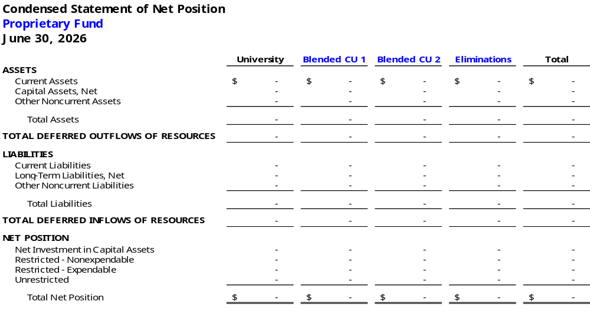
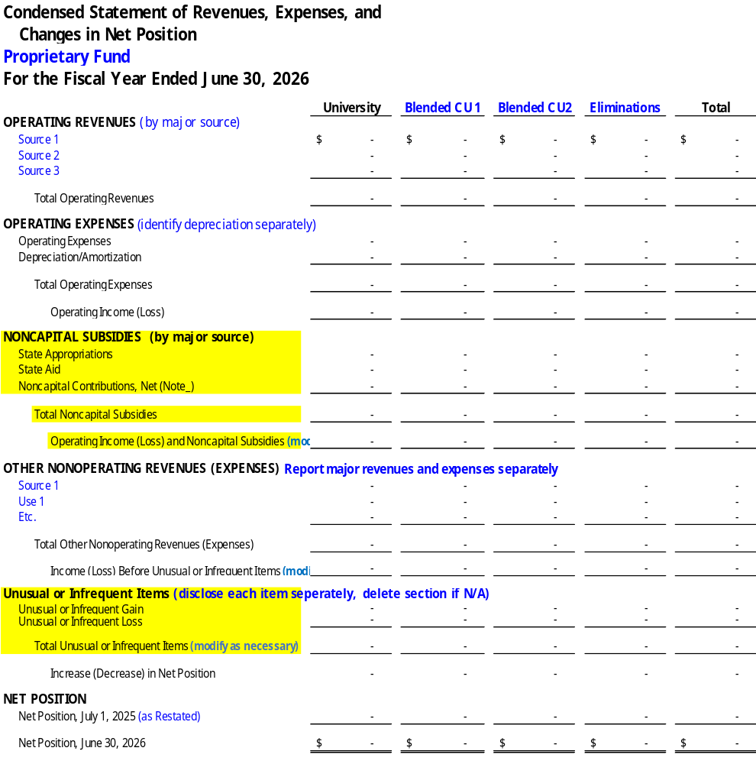
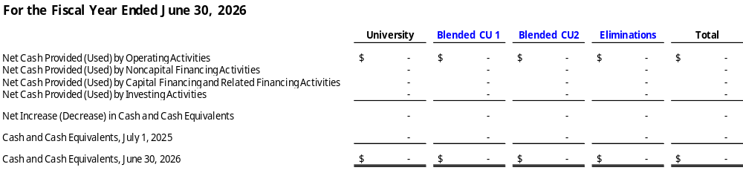

Note 24 - Changes in Financial Accounting and Reporting
For the fiscal year ended June 30, 2026, the University implemented the following pronouncement(s) issued by the Governmental Accounting Standards Board (GASB):
GASB Statement No. 103, Financial Reporting Model Improvements
GASB Statement No. 104, Disclosure of Certain Capital Assets
GASB Statement No. 103 improves key components of the financial reporting model to enhance its effectiveness in providing information that is essential for decision making and assessing accountability. The main areas that are impacted include: (1) Management’s Discussion and Analysis; (2) Unusual or Infrequent Items; (3) Presentation of the Proprietary Fund Statement of Revenues, Expenses, and Changes in Fund Net Position; (4) Major Component Unit Information; and (5) Budgetary Comparison Information. [Revise as needed.]
GASB Statement No. 104 provides users of government financial statements with essential information about certain types of capital assets. This Statement requires certain types of capital assets to be disclosed separately in the capital assets note disclosures required by Statement No. 34, Basic Financial Statements – and Management’s Discussion and Analysis – For State and Local Governments. Additional disclosures are required for capital assets held for sale. [Revise as needed.]

Note 25 - Net Position Restatement(s)
As of July 1, 2025, net position as previously reported was restated as follows: [Update table below with nature and description of the restatement (e.g., correct prior year accounting error). See GASB 100 paragraphs 14 through 30 for reporting requirements depending on the nature of the restatement. Modify as necessary.]
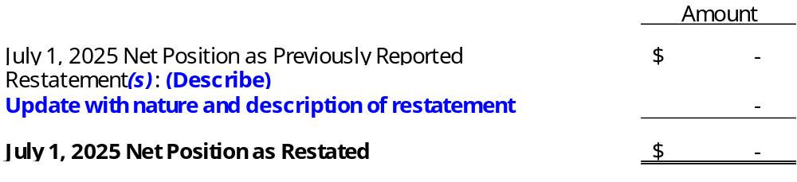

Note 26 - Subsequent Event(s)
[Describe significant events subsequent to the Statement of Net Position date through the report date. For example:]
On [date], the University of North Carolina Board of Governors ratified the issuance of bonds for a system-wide tax-exempt bond financing. The University intends to borrow approximately $_________ through the financing.

Required
Supplementary
Information

Insert Required Supplementary Information Here

